Table of Contents
Provided by: Crane Agency

The Employer’s Guide to COVID-19
Introduction 7
COVID-19 and Your Workforce 8
What Is COVID-19, and How Does It Spread? 8
Occupational Safety and Health Act of 1970 9
Disease Prevention in the Workplace 9
Responding to an Employee’s Positive Coronavirus Test 10
Responding to an Employee 10
Notifying Employees and Customers 11
Disinfecting the Office 11
Easing Employee Stress During the COVID-19 Pandemic 12
Reopening a Business After the Coronavirus Shutdown 13
Determining When to Reopen 13
Conducting a Risk Assessment 14
Maintaining Workplace Safety Using OSHA and CDC Guidance 15
Continued Safety 18
Families First Coronavirus Response Act 19
The Emergency Family and Medical Leave Expansion Act 19
Covered Employers 20
Covered Employees 21
Using Leave 22
Compensation 22
Job Protection 23
Tax Credit 23
The Emergency Paid Sick Leave Act 23
Covered Employers 24
Covered Employees 24
Using Paid Sick Leave 25
Employer Notice Requirements 26
Enforcement 26
Compensation 27
Tax Credit 27
Coronavirus Aid, Relief and Economic Security (CARES) Act 28
Overview 28
Changes for Health Plans 28
Overview 28
Coverage Requirement for Coronavirus Testing 29
Accelerated Coverage for COVID-19 Preventive Services and Vaccines…………………………………………. 30
HDHP Coverage of Coronavirus Costs 31
Tax-free Coverage for OTC Drugs and Menstrual Products 31
Loans to Small Businesses 32
Introduction 32
How Does the CARES Act Address Small Business Loans? 32
Overview of CARES Act Small Business Loan Provisions 32
Paycheck Protection Program Loans 33
SBA Economic Injury Disaster Loans 34
Expansion of Unemployment Benefits 36
Individual Checks to Taxpayers 37
Relief for Certain Federal Student Loans 37
Payments Suspended on Specific Loans 37
Interest Waived on Specific Loans 37
Collection Suspended on Specific Loans 38
Previous Student Loan Guidance 38
Aid to Public Health Institutions 38
HIPAA Privacy Considerations 40
Overview 40
Sharing Patient Information 40
Treatment 40
Public Health Activities 41
Disclosures to Family, Friends and Others Involved in an Individual’s Care and for Notification 41
Disclosures to Prevent a Serious and Imminent Threat 42
Disclosures to Media or Others Not Involved in the Care of the Patient/Notification 43
Minimum Necessary 43
Safeguarding Patient Information 44
HIPAA Applies Only to Covered Entities and Business Associates 44
Enforcement Discretion for Business Associates 45
Carrier Response to COVID-19 46
Introduction 46
What Costs Are Waived 46
UnitedHealthcare 46
Humana 46
Cigna 46
Aetna 47
What Does This Mean for Employers? 47
Layoffs and Furloughs 48
Furloughs 48
Layoffs 49
Continued Health Care Coverage 49
COBRA and State Continuation Coverage 50
Affordable Care Act (ACA) Employer Shared Responsibility Penalties 50
Wages Under the FLSA 51
The Families First Coronavirus Response Act (Families First Act) 51
Unemployment Compensation 52
Mass Layoffs 53
Other Compliance Considerations 55
Americans with Disabilities Act (ADA) 55
Introduction 55
EEOC Guidance 56
Overview 56
Occupational Safety and Health Act (OSHA) 63
Introduction 63
Overview 63
OSHA Interim Guidance 64
Hazard Recognition 64
Affecting OSHA Standards 64
State Standards 65
Control and Prevention 65
Workers’ Rights and Employers’ Responsibilities 65
Federal WARN Act 66
Introduction 66
Notice Triggers 66
Exceptions 68
State WARN Laws 68
Appendix 69
Remote Work Policy 70
CARES Act Infographic 74
Essential Worker Employee Communications Letter 75
Emergency Paid Sick Leave Act – Leave Request Form 76
Essential Business Notification Letter 78
National Coronavirus Guidelines for Americans Poster 79
Sample Telecommuting Arrangement Announcement Letter 80
Emergency Family and Medical Leave Expansion Act – Leave Request Form 81
Social Distancing Poster 82
Workplace Coronavirus Infection Email to Employees 83
Keep Surfaces Clean to Kill COVID-19 – Poster 84
10 Ways to Protect Against Coronavirus - Poster 85
Office Closing for Coronavirus Pandemic Employee Communications Letter 86
General Coronavirus Employee Communications Letter 87

Introduction
Coronavirus disease 2019 (COVID-19) is a respiratory disease caused by the SARS-CoV-2 virus that has spread from China to many other countries around the world, including the United States. The increased spread of the disease throughout the United States presents employers with significant workplace challenges. In order to help combat such challenges, we created this toolkit to help employers familiarize themselves with the best practices for handling the fallout.
This toolkit provides a comprehensive overview of the most pressing issues facing employers, including vital information regarding new federal laws such as the Families First Coronavirus Response Act (FFCRA) and Coronavirus Aid, Relief and Economic Security (CARES) Act, HIPAA privacy considerations, carrier response to the pandemic, layoffs and furloughs, tax credits and much more. However, please note that due to the developing nature of the pandemic, it is highly likely that the guidance found in this toolkit will require updating. Every effort will be made to continue to provide the most accurate, up-to-date information regarding COVID-19 and employer compliance considerations.
This toolkit is informative in nature and should not be used as a substitute for legal advice. For additional assistance, seek the help of legal counsel and a qualified insurance broker at Crane Agency.

This toolkit was last updated on: April 17, 2020.

COVID-19 and Your Workforce
As the number of reported cases of COVID-19 continues to rise, employers are increasingly confronted with the possibility of an outbreak in the workplace.
Employers are obligated to maintain a safe and healthy work environment for their employees, but are also subject to a number of legal requirements protecting workers, for instance, the Occupational Safety and Health Act (OSH Act). This section of the toolkit provides a summary of the actions employers should take when confronted with COVID-19 in the workplace.

What Is COVID-19, and How Does It Spread?
The COVID-19 is a disease caused by a member of the coronavirus family that is a close cousin to the SARS and MERS viruses that have caused outbreaks in the past. Symptoms of COVID-19 include fever, runny nose, cough and trouble breathing. Most people develop only mild symptoms. But some, usually people with other medical complications, develop more severe symptoms, including pneumonia, which can be fatal. The incubation period for COVID-19 is from two to 14 days.
Initially detected in Wuhan, China in late 2019, the first case of COVID-19 in the United States was reported on January 21, 2020. Since then, the disease has spread throughout the continental United States.
The available information about how the virus that causes COVID-19 spreads is largely based on what is known about similar coronaviruses. COVID-19 is a new disease, and there is more to learn about its transmission, the severity of illness it causes, and to what extent it may spread in the United States.
According to the CDC, the virus is thought to spread mainly from person to person, between people who are in close contact with one another (within about six feet) or through respiratory droplets produced when an infected person coughs or sneezes. These droplets can land in the mouths or noses of people who are nearby, or possibly be inhaled into the lungs. It may also be possible for a person to contract COVID-19 by touching a surface or object that has been contaminated with the virus and then touching his or her own mouth, nose, or eyes, but this is not thought to be the main way the virus spreads.
People are thought to be most contagious when they are most symptomatic. Some spread might be possible before people show symptoms, and there have been reports of this occurring, but this is not thought to be the main way the virus spreads.

Occupational Safety and Health Act of 1970
Under the federal Occupational Safety and Health Act of 1970 (the OSH Act), employers have a general duty to provide employees with safe workplace conditions that are “free from recognized hazards that are causing or are likely to cause death or serious physical harm.” Workers also have the right to receive information and training about workplace hazards, and to exercise their rights as employees without retaliation.
There is no specific Occupational Safety and Health Administration (OSHA) standard covering COVID-19. However, some OSHA requirements may apply to preventing occupational exposure to COVID-19. In addition to the General Duty clause, OSHA’s Personal Protective Equipment (PPE) standards and Bloodborne Pathogens standard may apply to certain workplaces, such as those in the healthcare industry.
Employers should continue to monitor the development of COVID-19 and analyze whether employees could be at risk of exposure. It is also important for employers to consider what preventive measures they can take to maintain safety and protect their employees from potentially contracting COVID-19.
Also, OSHA requires many employers to record certain work-related injuries and illnesses on their OSHA Form 300 (OSHA Log of Work-Related Injuries and Illnesses). OSHA has determined that COVID-19 is a recordable illness when a worker is infected on the job. Establishments that are required to complete an OSHA 300 log should be sure to include all COVID-19 infections that are work-related.

Disease Prevention in the Workplace
Whenever a communicable disease outbreak is possible, employers may need to take precautions to keep the disease from spreading through the workplace. It is recommended that employers establish a written policy and response plan that covers communicable diseases readily transmitted in the workplace.
Employers can require employees to stay home from work if they have signs or symptoms of a communicable disease that poses a credible threat of transmission in the workplace, or if they have traveled to high-risk geographic areas, such as those with widespread or sustained community transmission of the illness. When possible, employers can consider allowing employees to work remotely. Employers may require employees to provide medical documentation that they can return to work.
Employers can consider canceling business travel to affected geographic areas and may request that employees notify them if they are traveling to these areas for personal reasons. Employees who travel to China should be informed that they may be quarantined or otherwise required to stay away from work until they can provide medical documentation that they are free of symptoms.
There are several legal considerations that employers should keep in mind when implementing and administering a communicable illness policy. These considerations are addressed in the following sections.

Responding to an Employee’s Positive Coronavirus Test
As the number of COVID-19 cases grows daily, employers across the country are dealing with the difficult situation of responding to an employee’s positive COVID-19 test.
Employers are responsible for handling the situation swiftly to protect the health of other employees while preserving the affected employee’s confidentiality. In addition to notifying the company and its customers, employers must also disinfect the office and evaluate next steps.

Responding to an Employee
When an employee notifies you that he or she is sick with COVID-19, you should respond calmly and empathetically. In these uncertain times, it can be easy to overreact, but you need to ensure that the infected employee is treated with compassion. Reassure the employee that their identity will remain confidential, and be sure to help them coordinate taking leave or paid time off until they’ve recovered.
You will also need to ask the employee some potentially difficult questions, including whom the employee has been in contact with in the last two weeks. Obtaining this information is essential so that you can directly notify customers and other employees that they may have been directly exposed to COVID-19.

Notifying Employees and Customers
Without disclosing the identity of the infected employee, you need to notify their co-workers, customers and the rest of the company.
Directly notify any co-workers or customers whom the ill employee had been in contact with. Be sure to remain calm and let them know that someone they have been in contact with or has been in their physical work area has tested positive for COVID-19. Recommend that they should self-quarantine for the next 14 days and monitor themselves for the symptoms of COVID-19. If feasible, allow eligible employees to work from home during this time.
Be sure to notify the rest of the company by email or letter that an employee has tested positive for COVID-19. Remember to keep the employee’s identity protected and be transparent about your response. The communication should include what steps your company will be taking to protect the health of other employees. If you plan on having employees work from home for the next 14 days or closing the office, this information should be disclosed in the communication.

Disinfecting the Office
According to the Centers for Disease Control and Prevention (CDC), COVID-19 can remain on hard surfaces for up to 12 hours, creating a potential risk of transmission. Depending on the size of your organization, you may want to consider closing the office for a few days so that it can be thoroughly cleaned and disinfected. All surfaces that the infected employee may have touched should be disinfected, as well as other high-touch surfaces, which include countertops, cabinets, doorknobs, handles and chairs.

Easing Employee Stress During the COVID-19 Pandemic
As the number of confirmed cases increases daily, employees and their families are experiencing immense uncertainty. In times such as these, employees are looking for guidance wherever they can find it. Employers can help calm some of their employees’ fears by taking the following actions:
- Acknowledge employee fears surrounding their jobs and the company, but also reassure them of their value to the company and the company’s desire to keep them as members of the team.
- Be open with employees about management decisions and ask for suggestions to rectify problems.
- Provide as much information as possible about the pandemic.
- Highlight employee benefits that employees might not know about to relieve any financial stress.
- Encourage employees to take advantage of any telehealth services to preserve their mental well-being.
- Communicate the future of the business with employees often—in meetings, on the company intranet site, in newsletters and in blogs.
- Be empathetic in your communications, as every employee’s situation may be different.
In these uncertain times, it’s imperative that you clearly communicate your business’s plans as frequently as possible. It’s not possible for you to control the pandemic, but it is possible for you to help ease the stress your employees are experiencing.

Reopening a Business After the Coronavirus Shutdown
As the coronavirus (COVID-19) pandemic continues to have an unprecedented effect on daily life, many business owners are looking forward to the future and a return to normalcy. However, even when stay-at-home orders are lifted and nonessential businesses are allowed to resume operations, there’s a lot for organizations to consider before they reopen their doors. What’s more, many of these considerations are workplace-specific and could be more involved depending on the industry you operate in.
To protect their customers and employees alike, it’s important for organizations to do their due diligence before opening their business back up to the public following the COVID-19 pandemic.

Determining When to Reopen
While many essential businesses (e.g., hospitals, pharmacies, grocery stores and gas stations) have remained open during the COVID-19 pandemic, other operations deemed nonessential have shut down temporarily or changed the nature of their operations. Not only has this led to significant business disruptions, but, for many, it has critically impacted their bottom line.
However, we may be nearing a time when stay-at-home regulations are scaled back and all businesses are allowed to resume as normal. President Trump released his guidelines for “Opening Up America Again,” an 18-page document with general guidance that state governors may use to reopen businesses by May 1. Ultimately, reopening businesses will be the decision of state governors, so monitor local news outlets for updates.
With these uncertainties, the question then is: How will business owners know it is acceptable to reopen? The following are some best practices to keep in mind:
- Review guidance from state and local governments—The COVID-19 pandemic impacts states and regions in different ways. Just because a business is allowed to reopen in one region of the country doesn’t automatically mean your operations will be allowed to resume as well. As such, it’s critical to understand and review all relevant state and local orders to determine if and when your business is allowed to reopen.
- Understand the risks—If and when the government allows all businesses to reopen, that doesn’t necessarily mean COVID-19 is no longer a threat to your operations. What’s more, some businesses may have greater COVID-19 exposures than others, underscoring the importance of performing a thorough risk assessment before reopening. Prior to conducting a risk assessment, it’s important to review guidance from the Occupational Safety and Health Administration (OSHA), state and local agencies, industry associations as well as your local health department. More information on conducting a risk assessment can be found below.
Again, before reopening, it’s critical to seek the expertise of legal, insurance and other professionals.

Conducting a Risk Assessment
Even after the government allows businesses to reopen, firms still need to determine if it makes sense to resume operations. Safely restarting your business won’t be as simple as unlocking the front door.
Before reopening, businesses should perform a risk assessment to determine what steps must be taken. While the complexity of risk assessments will differ from business to business, they typically involve the following steps:
- Identifying the hazards—When it comes to COVID-19, businesses need to think critically about their exposures, particularly if an infected person entered their facilities. When identifying hazards, it’s a good idea to perform a walkthrough of the premises and consider high-risk areas (e.g., breakrooms and other areas where people may congregate). It’s also important to consider what tasks employees are performing and whether or not they are especially exposed to COVID-19 risks when performing their duties.
- Deciding who may be harmed and how—Once you’ve identified hazards to your business, you need to determine what populations of your workforce are exposed to COVID-19 risks. When performing this evaluation, you will need to make note of high-risk individuals (e.g., staff members who meet with customers or individuals with preexisting medical conditions).
- Assessing risks—Once you have identified the risks facing your business, you must analyze them to determine their potential consequences. For each risk facing your business, you’ll want to determine:
  - How likely is this particular risk to occur?
  - What are the ramifications should this risk occur?
When analyzing your risks, consider potential financial losses, compliance requirements, employee safety, business disruptions, reputational harm and other consequences.
- Controlling risks—With a sense of what the threats to your business are, you can then consider ways to address them. There are a variety of methods businesses can use to manage their risks, including:
  - Risk avoidance—Risk avoidance is when a business eliminates certain hazards, activities and exposures from their operations altogether.
  - Risk control—Risk control involves preventive action.
  - Risk transfer—Risk transfer is when a business transfers their exposures to a third party.
For COVID-19, control measures could include cleaning protocols, work from home orders and mandated personal protective equipment (PPE) usage. Additional workplace considerations can be found below.
- Monitoring the results—Risk management is an evolving, continuous process. Once you’ve implemented a risk management solution, you’ll want to monitor its effectiveness and reassess. Remember, COVID-19 risks facing your business can change over time.

Maintaining Workplace Safety Using OSHA and CDC Guidance
Once you conduct a risk assessment, you will need to act to control COVID-19 risks. Again, risks and the corrective steps that organizations take to address those risks will vary by business and industry.
Thankfully, there are a number of OSHA and Center for Disease Control and Prevention (CDC) workplace controls to consider if your risk assessment determines that COVID-19 poses a threat to your employees or customers. For instance, you should:
- Implement administrative controls—Typically, administrative controls are changes in work policies or procedures that reduce or minimize an individual’s exposure to a hazard. An example of an administrative control for COVID-19 is establishing alternating days or extra shifts that reduce the total number of employees in a facility at a given time.
- Utilize Personal Protective Equipment (PPE)— PPE is equipment worn by individuals to reduce exposure to a hazard, in this case, CVOID-19. Businesses should focus on training workers on and proper PPE best practices. Employees should understand how to properly put on, take off and care for PPE. Training material should be easy to understand and must be available in the appropriate language and literacy level for all workers.
- Consider engineering controls—Engineering controls protect workers by removing hazardous conditions or by placing a barrier between the worker and the hazard. For COVID-19, engineering controls can include:
  - Installing high-efficiency air filters
  - Increasing ventilation rates in the work environment
  - Installing physical barriers, such as clear plastic sneeze guards
- Be adaptable—You should be prepared to change your business practices if needed to maintain critical operations. This could involve identifying alternative suppliers, prioritizing existing customers or suspending portions of your operations.
- Create a dialogue with vendors and partners—Talk with business partners about your response plans. Share best practices with other businesses in your communities, and especially those in your supply chain.
- Encourage social distancing—Social distancing is the practice of deliberately increasing the physical space between people to avoid spreading illness. In terms of COVID-19, social distancing best practices for businesses can include:
  - Avoiding gatherings of 10 or more people
  - Instructing workers to maintain at least 6 feet of distance from other people
  - Hosting meetings virtually when possible
  - Limiting the number of people on the jobs site to essential personnel only
  - Encouraging or requiring staff to work from home when possible
  - Discouraging people from shaking hands
- Manage the different risk levels of their employees—It’s important to be aware that some employees may be at higher risk for serious illness, such as older adults and those with chronic medical conditions. Consider minimizing face-to-face contact between these employees or assign work tasks that allow them to maintain a distance of 6 feet from other workers, customers and visitors.
- Separate sick employees—Employees who appear to have symptoms (i.e., fever, cough or shortness of breath) upon arrival at work or who become sick during the day should immediately be separated from other employees, customers and visitors, and sent home. If an employee is confirmed to have COVID-19, employers should inform fellow employees of their possible exposure to COVID-19. The employer should instruct fellow employees about how to proceed based on the CDC Public Health Recommendations for Community-Related Exposure.
- Support respiratory etiquette and hand hygiene—Businesses should encourage good hygiene to prevent the spread of COVD-19. This can involve:
  - Providing tissues and no-touch disposal receptacles
  - Providing soap and water in the workplace
  - Placing hand sanitizers in multiple locations to encourage hand hygiene
- Perform routine environmental cleaning and disinfection—Businesses should regularly sanitize their facility to prevent the spread of COVID-19. Some best practices include:
  - Cleaning and disinfecting all frequently touched surfaces in the workplace, such as workstations, keyboards, telephones, handrails and doorknobs.
  - Discouraging workers from using other workers’ phones, desks, offices, or other tools and equipment, when possible. If necessary, clean and disinfect them before and after use.
  - Providing disposable wipes so that commonly used surfaces can be wiped down by employees before each use.

Continued Safety
While resuming operations following the COVID-19 pandemic may seem like a daunting task, businesses don’t have to go it alone. To help with this process, organizations can seek the help of their insurance professionals to determine what actions they need to take to ensure their business reopens smoothly. To learn more, contact Crane Agency today.

Families First Coronavirus Response Act
As part of the Families First Coronavirus Response Act (FFCRA) signed into law by President Trump on March 18, 2020, two laws were enacted that provide workers with paid leave for reasons related to the COVID-19 pandemic. One of the new leave laws, the Emergency Family and Medical Leave Expansion Act, allows 12 weeks of partially compensated FMLA leave to care for a child whose school or child care facility has been closed due to COVID-19. The leave applies only to workers who have been employed by their current employer for 30 days.
The other new law providing employee leave, the Emergency Paid Sick Leave Act, requires employers to provide 80 hours of paid sick time to employees in specified circumstances, including:
- A quarantine or isolation order for the employee or someone the employee is caring for, or medical advice to self-quarantine;
- When the employee has symptoms of COVID-19; or
- When the employee’s child’s school or child care facility is closed.
Employers with 500 employees or more are exempt from the laws, and employers may exclude employees who are health care providers and emergency responders. The legislation also allows for future regulations exempting businesses with fewer than 50 employees from providing leave for child care reasons if the leave would jeopardize the viability of the business. The leave benefits took effect on April 1, 2020, and expire on Dec. 31, 2020.

The Emergency Family and Medical Leave Expansion Act
To alleviate the effects of the COVID-19 pandemic, Congress enacted the FFCRA, which included two separate laws mandating paid employee leave for specific COVID-19 purposes. The two leave laws are the Emergency Family and Medical Leave Expansion Act and the Emergency Paid Sick Leave Act. The leave mandates took effect on April 1, 2020, and sunset on Dec. 31, 2020. This guide will begin with the Emergency Family and Medical Leave Expansion Act.

Covered Employers
The expanded FMLA requirements apply to private employers with fewer than 500 employees, and some government employers. Thus, small employers that are not subject to the FMLA’s regular leave provisions are subject to the new FMLA leave rules that allow employees to take leave for specified child care purposes related to COVID-19.
However, the law allows for future regulations to exempt businesses with fewer than 50 employees if the leave would jeopardize the viability of the business. The DOL has issued guidance stating that a small business may claim this exemption if an authorized officer of the business has determined that:
- The provision of expanded family and medical leave would result in the small business’s expenses and financial obligations exceeding available business revenues and cause the small business to cease operating at a minimal capacity;
- The absence of the employee or employees requesting expanded family and medical leave would entail a substantial risk to the financial health or operational capabilities of the small business because of their specialized skills, knowledge of the business, or responsibilities; or
- There are not sufficient workers who are able, willing, and qualified, and who will be available at the time and place needed, to perform the labor or services provided by the employee or employees requesting expanded family and medical leave, and these labor or services are needed for the small business to operate at a minimal capacity.
The law further stipulates that employers with fewer than 50 employees will not be subject to civil damages in an employee action brought under the FMLA for violation of the new provisions.

Covered Employees
All employees who have worked for their current employer for 30 calendar days are eligible for the new FMLA leave; however, employers are permitted to deny leave to employees who are health care providers or emergency responders.
DOL Q&As on the new laws state that a health care provider is anyone employed at any doctor’s office, hospital, health care center, clinic, post-secondary educational institution offering health care instruction, medical school, local health department or agency, nursing facility, retirement facility, nursing home, home health care provider, any facility that performs laboratory or medical testing, pharmacy, or any similar institution, employer, or entity. This includes any permanent or temporary institution, facility, location, or site where medical services are provided that are similar to such institutions.
The DOL guidance explains further that the definition includes any individual employed by an entity that contracts with any of the above institutions, employers, or entities to provide services or maintain the operation of the facility. It also includes anyone employed by any entity that provides medical services, produces medical products, or is otherwise involved in the making of COVID-19-related medical equipment, tests, drugs, vaccines, diagnostic vehicles, or treatments. This also includes any individual that the highest official of a state or territory, including the District of Columbia, determines is a health care provider necessary for that state’s or territory’s—or the District of Columbia’s—response to COVID-19.
To minimize the spread of the virus associated with COVID-19, DOL encourages employers to be judicious when using this definition to exempt health care providers from the provisions of the FFCRA.
Most public federal employees are not covered by the FMLA expansion because the law amended only Title I of the FMLA, and most federal employees are covered by Title II. However, most non-federal employees of public agencies are covered by the expanded FMLA leave. The health care provider and emergency responder exemptions described above also apply to public-sector employees.

Using Leave
Eligible employees of covered employers may take up to 12 weeks of FMLA leave if they are unable to work (or telework) because they must care for a son or daughter under 18 years of age. The need for leave must be caused by the closing of the child’s elementary or high school or place of care, or the unavailability of the child’s child care provider, due to a declared COVID-19 public health emergency.
DOL Q&As clarify that “son or daughter” means the employee’s own child, including a biological, adopted, or foster child; a stepchild; a legal ward; or a child for whom the employee is standing in loco parentis—someone with day-to-day responsibilities to care for or financially support a child. Adult children are included if they have a disability that renders them incapable of self-care.
“Child care provider” means a provider who receives compensation for providing child care services on a regular basis.
DOL Q&As on the new laws explain that if an employer was covered by the FMLA before April 1, 2020, an employee is limited to 12 weeks of total FMLA leave (including expanded FMLA leave) during the 12-month period the employer uses for FMLA leave.
Where the need for leave is foreseeable, employees should provide their employers with as much notice of leave as is practicable.

Compensation
Employers are not required to pay employees for the first 10 days of the new FMLA leave, but employees may substitute any accrued vacation leave, personal leave, or medical or sick leave for this unpaid leave. Thereafter, the employer must compensate FMLA leave taken under the new provision at a rate of at least two-thirds of the employee’s regular rate of pay, based on the number of hours the employee would otherwise normally be scheduled to work, up to a maximum of $200 per day, or $10,000 total.
Special calculation rules apply for employees with variable schedules, and special rules apply to multi-employer collective bargaining agreements.

Job Protection
While FMLA leave is usually job-protected, meaning employees who take leave must be restored to their position (or an equivalent) when they return to work, the new law provides a limited exception to this requirement. Employers with fewer than 25 employees are not subject to the job restoration requirement, if:
- The employee took FMLA leave under the new COVID-19 expansion of the law;
- The employee’s position no longer exists due to economic conditions or changes in operating conditions of the employer that affect employment and are caused by a public health emergency;
- The employer makes reasonable efforts to restore the employee to an equivalent position; and
- If these efforts fail, the employer makes reasonable efforts to contact the employee if an equivalent position becomes available. The contact period is for one year, beginning on the earlier of:
  - The date on which the employee’s need for leave ends
  - Twelve weeks after the employee’s leave begins

Tax Credit
Employers are entitled to a credit against the tax imposed by section 3111(a) or 3221(a) of the IRS Code for each calendar quarter of an amount equal to 100% of qualified family leave wages paid. Tax credits are also available for self-employed people.

The Emergency Paid Sick Leave Act
The second federal law passed providing paid employee leave in relation to the coronavirus is the Emergency Paid Sick Leave Act.

Covered Employers
The paid sick leave law applies to all private employers with fewer than 500 employees, and all government employers. The law allows for future regulations exempting businesses with fewer than 50 employees from providing leave for specific child care reasons under certain conditions, described later in this document in the Using Paid Sick Leave section.

Covered Employees
All employees are covered by the Emergency Paid Sick Leave Act, regardless of the length of their employment with their current employer. However, as with the expanded FMLA leave, employers may choose not to provide paid sick leave to employees who are health care providers or emergency responders. As with the exemption to expanded FMLA leave, DOL Q&As define these workers as anyone employed at any doctor’s office, hospital, health care center, clinic, post-secondary educational institution offering health care instruction, medical school, local health department or agency, nursing facility, retirement facility, nursing home, home health care provider, any facility that performs laboratory or medical testing, pharmacy, or any similar institution, employer or entity. This includes any permanent or temporary institution, facility, location, or site where medical services are provided that are similar to such institutions.
The definition also includes any individual employed by an entity that contracts with any of the above institutions, employers, or entities to provide services or maintain the operation of the facility. It also includes anyone employed by any entity that provides medical services, produces medical products, or is otherwise involved in the making of COVID-19-related medical equipment, tests, drugs, vaccines, diagnostic vehicles, or treatments. This also includes any individual that the highest official of a state or territory, including the District of Columbia, determines is a health care provider necessary for that state’s or territory’s—or the District of Columbia’s—response to COVID-19.
DOL encourages employers to be judicious using this definition to exempt health care providers from the provisions of the law.
Most government employees are covered by the Emergency Paid Sick Leave Act.

Using Paid Sick Leave
All full-time employees (normally scheduled to work 40 or more hours per week) are entitled to 80 hours of paid sick time, available for immediate use, regardless of the length of time they have worked for their employer. Part-time employees (normally scheduled to work fewer than 40 hours per week) are entitled to an amount of paid sick time equal to the average number of hours they work over a two-week period.
Paid sick time may be taken when the employee:
- Is subject to a federal, state or local quarantine or isolation order related to COVID-19
- Has been advised by a health care provider to self-quarantine due to concerns related to COVID-19
- Is experiencing symptoms of COVID-19 and is seeking a medical diagnosis
- Is caring for an individual who is subject to a federal, state or local quarantine or isolation order related to COVID-19, or who has been advised by a health care provider to self-quarantine
- Is caring for his or her son or daughter if the child’s school or place of care has closed, or the child’s care provider is unavailable, because of COVID-19 precautions
- Is experiencing another substantially similar condition specified by the Secretary of Health and Human Services (HHS)
DOL Q&As clarify that “son or daughter” means the employee’s own child, including a biological, adopted, or foster child; a stepchild; a legal ward; or a child for whom the employee is standing in loco parentis. Children 18 or over are included if they have a disability that renders them incapable of self-care.
The law allows for future regulations exempting businesses with fewer than 50 employees from providing leave related to school or child care unavailability (reason 5, above), if the leave would jeopardize the viability of the business as a going concern. According to DOL guidance, the exemption may be claimed if an authorized officer of the business has determined that one of the following conditions is satisfied:
- The provision of paid sick leave would result in the small business’s expenses and financial obligations exceeding available business revenues and cause the small business to cease operating at a minimal capacity;
- The absence of the employee or employees requesting paid sick leave would entail a substantial risk to the financial health or operational capabilities of the small business because of their specialized skills, knowledge of the business, or responsibilities; or
- There are not sufficient workers who are able, willing, and qualified, and who will be available at the time and place needed, to perform the labor or services provided by the employee or employees requesting paid sick leave, and these labor or services are needed for the small business to operate at a minimal capacity.
Employers may not require employees to use other paid leave before using paid leave under the new law; however, an employer may require an employee to follow reasonable notice procedures after taking leave for the first time.

Employer Notice Requirements
Employers must post this notice in conspicuous places on their premises, where notices to employees are customarily posted. An employer may satisfy this requirement by emailing or direct mailing this notice to employees, or posting the notice on an employee information internal or external website.

Enforcement
Employers who violate the new paid sick leave law will be subject to penalties under the federal Fair Labor Standards Act. The DOL has issued guidance saying it will not bring enforcement actions against any employer for violations of either leave provision in the FFCRA occurring within the first 30 days after it was passed (March 18 through April 17, 2020). This reprieve from enforcement only applies if the employer has made reasonable, good faith efforts to comply with the Act.

Compensation
Reason for leave | Daily pay rate/cap | Total pay cap
Quarantine or isolation order | Regular rate of pay up to a cap of $511 | $5,110
Advice from health care provider to self-quarantine
Experiencing symptoms of COVID-19 and seeking a medical diagnosis
Caring for an individual subject to quarantine or isolation order, or who has been advised by a health care provider to self-quarantine | Two-thirds regular rate of pay, up to a cap of $200 | $2,000
Caring for own child whose school or place of care has closed, or whose care provider is closed or unavailable
Experiencing other substantially similar condition specified by HHS
Employee compensation under the Emergency Paid Sick Leave Act varies according to the reason for the leave, as set forth in the table below:
Special calculation rules apply for part-time employees with variable work schedules.

Tax Credit
Employers are entitled to a credit against the tax imposed by section 3111(a) or 3221(a) of the IRS Code for each calendar quarter, of an amount equal to 100% of qualified sick leave wages paid. Tax credits are also available for the self-employed.

Coronavirus Aid, Relief and Economic Security (CARES) Act

Overview
On Friday, March 27, 2020—after days of debate—the president approved a $2 trillion economic rescue package designed to provide financial assistance to Americans and their families, and billions of dollars in loans for businesses. The package is the largest fiscal stimulus in modern U.S. history and is the government’s most recent response to COVID-19.
The economic rescue package includes a plan to provide direct financial assistance to Americans, a plan to stabilize the airline industry, a plan to provide small businesses with funds and a plan to issue loan guarantees to other hard-hit sectors in the economy. The package also includes provisions to extend unemployment insurance, increase funding for Medicaid and add additional assistance for small businesses throughout the country.
Below please find overviews of the most pertinent provisions for employers.

Changes for Health Plans

Overview
The CARES Act, a $2 trillion economic rescue package, makes a variety of changes affecting health plans. These changes include:
- Expanding the types of coronavirus testing that all health plans and health insurance issuers must cover without cost-sharing (such as deductibles, copayments or coinsurance) or prior authorization;
- Accelerating the process that will require health plans and issuers to cover preventive services and vaccines related to COVID-19;

- Allowing telehealth and other remote care services to be covered under a high deductible health plan (HDHP) before the deductible is met, without affecting the HDHP’s compatibility with health savings accounts (HSAs) (applicable for HDHP plan years beginning on or before Dec. 31, 2021); and
- Treating over-the-counter (OTC) medications, along with menstrual care products, as qualified medical expenses that may be paid for using HSAs or other tax-advantaged arrangements, such as health flexible spending accounts (FSAs) or health reimbursement arrangements (HRAs).

Coverage Requirement for Coronavirus Testing
Effective March 18, 2020, the FFCRA requires group health plans and health insurance issuers to cover COVID-19 testing without imposing any cost sharing (such as deductibles, copayments or coinsurance) or prior authorization or other medical management requirements. The CARES Act expands the FFCRA’s coverage requirement for COVID-19 testing.
Coverage Mandate
This coverage mandate applies to the following health plans and issuers, regardless of grandfathered status under the Affordable Care Act (ACA):
- All fully insured group health plans
- All self-insured group health plans
- Health insurance issuers offering group or individual coverage
During the COVID-19 public health emergency, health plans and issuers must cover FDA-approved diagnostic testing products for COVID-19, including any items or services provided during a visit to a provider (in-person or telehealth), urgent care center or emergency room that relate to COVID-19 testing.
Effective March 27, 2020, the CARES Act expands this coverage mandate to include COVID-19 tests provided on an emergency basis, state-developed tests and any other tests approved by the U.S. Department of Health and Human Services.
This coverage cannot be subject to any plan deductible, copayment or coinsurance.
Provider Reimbursement Rates
The CARES Act also addresses provider reimbursement rates for COVID-19 testing. A health plan or issuer must pay a health care provider the negotiated rate for COVID-19 testing. However, if a health plan or issuer does not have a negotiated rate with a provider, it must pay the cash price published by the provider on its public website or negotiate or lower price.

Accelerated Coverage for COVID-19 Preventive Services and Vaccines
The ACA requires non-grandfathered group health plans and health insurance issuers to cover certain preventive health services without imposing cost-sharing requirements for the services. The recommended preventive care services covered by these requirements are:
- Evidence-based items or services that have in effect a rating of A or B in the current recommendations of the United States Preventive Services Task Force (USPSTF);
- Immunizations for routine use in children, adolescents and adults that are currently recommended by the CDC and included on the CDC’s immunization schedules;
- For infants, children and adolescents, evidence-informed preventive care and screenings provided for in the Health Resources and Services Administration (HRSA) guidelines; and
- For women, evidence-informed preventive care and screening provided in guidelines supported by HRSA.
In general, health plans and issuers are not required to cover a new preventive care recommendation or guideline until at least one year after the new recommendation or guideline goes into effect.
The CARES Act shortens this deadline to ensure that health plans and issuers cover COVID-19 preventive services and vaccines without cost-sharing once they are approved and available. Under the CARES Act, health plans and issuers must cover COVID-19 preventive services and vaccinations without cost-sharing within 15 days after a recommendation from USPSTF or the CDC.

HDHP Coverage of Coronavirus Costs
Only individuals who are covered by HDHPs can make contributions to HSAs. To qualify as an HDHP, a health plan cannot pay medical expenses (other than preventive care) until the annual minimum deductible has been reached. IRS Notice 2020-15 and the CARES Act provide exceptions to this general rule to encourage testing for and treatment of COVID-19.
- IRS Notice 2020-15 provides that HDHPs can pay for COVID-19 testing and treatment before plan deductibles have been met, without jeopardizing their status. As noted above, the FFCRA requires health plans and issuers to cover COVID-19 testing without imposing any cost sharing or prior authorization or other medical management requirements.
- Effective March 27, 2020, the CARES Act allows HDHPs to provide benefits for telehealth or other remote care services before plan deductibles have been met. This rule is applicable for plan years beginning before Jan. 1, 2022. This is a discretionary change for employer-sponsored health plans, and not a coverage mandate.

Tax-free Coverage for OTC Drugs and Menstrual Products
Effective Jan. 1, 2020, the CARES Act provides that OTC medicines are qualifying medical expenses that may be paid for (or reimbursed) on a tax-free basis by an HSA, health FSA or HRA. This change eliminates an ACA provision that required individuals to have a prescription for an OTC medication (except insulin) to pay for it on a tax-free basis with their HSA, health FSA or HRA.
In addition, effective Jan. 1, 2020, menstrual care products are qualifying medical expenses that can be paid for (or reimbursed) on a tax-free basis by an HSA, health FSA or HRA. Menstrual care products include tampons, pads, liners, cups, sponges or similar products used by individuals with respect to menstruation.
These changes are discretionary for employers that sponsor health FSAs and HRAs. However, because HSAs are individual accounts, and not employer plans, employers do not control how HSA funds are used.

Loans to Small Businesses

Introduction
The CARES Act provides businesses suffering under the debilitating effects of the pandemic with unprecedented access to emergency loans. This document will serve as an overview of the loan programs available.

How Does the CARES Act Address Small Business Loans?
The CARES Act is the largest economic stimulus measure in modern history and promises to provide help for struggling American families and businesses. Specifically, the Act includes the following provisions:
- The Act includes nearly $350 billion for a federal small business loan program called the Paycheck Protection Program. The program is designed to get cash in the hands of suffering small businesses quickly, with less stringent eligibility requirements than the existing U.S. Small Business Association (SBA) loan programs. Paycheck Protection Program loans are designed to incentivize business owners to keep employees on payroll.
- In addition to businesses already eligible for SBA programs, most businesses with 500 or fewer employees are now eligible for disaster loans of up to $2 million for working capital. Those businesses will also be eligible for an emergency cash advance of $10,000 within days of making the application, which is not repayable even if their loan application is denied.

Overview of CARES Act Small Business Loan Provisions
As noted above, the CARES Act provides two main avenues for obtaining a business loan:
- Through the Paycheck Protection Program
- Through the SBA as a disaster loan
Below you will find an overview of the eligibility requirements, key loan terms, and how to apply for each program.

Paycheck Protection Program Loans
The CARES Act allocated $350 billion to help small businesses keep workers employed amid the pandemic and economic downturn. Included in the CARES Act was the Paycheck Protection Program, which provides 100% federally guaranteed loans to small businesses, through Jun. 30, 2020. Importantly, these loans may be forgiven if borrowers maintain their payrolls during the crisis. Though information on the program continues to be rolled out, the following is an overview of information available now:
Eligibility
You are eligible for a loan under this program if you are:
- A small business that was in operation on Feb. 15, 2020, with fewer than 500 employees (The 500-employee threshold includes all employees: full-time, part-time and any other status.)
- A small business that otherwise meets the SBA’s size standard
- A 501(c)(3) with fewer than 500 employees
- An individual who operates as a sole proprietor
- An individual who operates as an independent contractor
- An individual who is self-employed and who regularly carries on any trade or business
- A tribal business concern that meets the SBA’s size standard
- A 501(c)(19) Veterans Organization that meets the SBA’s size standard

Terms of the Loan
The terms of a Paycheck Protection Program loan are as follows:
- The amount of a Paycheck Protection Program loan available to each borrower is 2.5 times the borrower’s average monthly payroll costs, not to exceed $10 million.
- Paycheck Protection Program loans require no collateral, have a maximum 10-year term, and an interest rate of no more than 4%.
- The loans are available to eligible companies to be used for the following costs incurred from Feb. 15, 2020, through June 30, 2020: payroll (including salary, wage, parental, family, medical or sick leave, and more); health care benefits and related insurance premiums; employee compensation; mortgage interest obligations; and rent and utilities.
- A borrower of a Paycheck Protection Program loan is eligible for loan forgiveness equal to the amount spent during the eight-week period after the date of the original loan for rent on a leasing agreement, payroll costs (including wages for USA employees capped at $100,000 per employee), mortgage interest and utilities. The amount forgiven may be reduced if the borrower reduces the number of employees, or salaries and wages of employees. Borrowers must apply through their lender for forgiveness of the loan.
How to Apply for a Paycheck Protection Program Loan
The application has been posted on the Treasury Department’s CARES Act resource page. The SBA has a network of 1,800 approved lenders that process small business loans. If you are interested in a Paycheck Protection Program loan, you should first contact your bank to see if it is an SBA-approved lender. If your bank is not an SBA-approved lender, you can contact the SBA to find one.

SBA Economic Injury Disaster Loans
Another option for small businesses is the SBA’s existing Economic Injury Disaster Loan (EIDL) Program, which was expanded by the CARES Act and provides for longer-term loans with favorable borrowing terms. Companies in all 50 states, District of Columbia, and some U.S. territories are typically eligible for EDIL loans relating to economic injury caused by the COVID-19 pandemic, and will be available until Dec. 31, 2020.
Eligibility
The CARES Act expanded EIDL loan eligibility for the period between Jan. 31, 2020, and Dec. 31, 2020, to include:
- Businesses with 500 or fewer employees
- Sole proprietorships and independent contractors with or without employees
- Private nonprofits and cooperatives
- Tribal small business concerns and ESOPs with 500 or fewer employees
If your business meets the aforementioned requirements and your revenues have suffered substantial economic injury from COVID-19, your business is eligible no matter your line of business.
Terms of the Loan
The terms of an EIDL loan are outlined below:
- The amount of an EIDL loan available to each borrower is the business’s actual economic injury as determined by the SBA, not to exceed $2 million.
- EIDL loans under the CARES Act do not require personal guarantees for loans up to $200,000, but the SBA will take a collateral interest in your business’s assets to the extent available.
- The interest rate on EIDL loans is 3.75% fixed for small businesses and 2.75% for nonprofits. EIDL loans have up to a 30-year term. Specific terms will be determined on a case-by-case basis, based upon each borrower’s ability to repay the loan.
- EIDL loans may be used for payroll, debts and to pay obligations that cannot be met due to the pandemic.
- Your business may be approved for an EIDL loan based on credit score alone, without being required to submit tax returns.
The CARES Act also permits applicants to request an advance of up to $10,000, which may be used to keep employees on payroll, to pay for sick leave, meet increased production costs, or pay business obligations. If you apply, the advance should be paid to your business within three days. This advance, available backdated from Jan.31, 2020 to Dec. 31, 2020, is not required to be repaid even if your application is denied. To access this advance, borrowers must first apply for an EIDL and then request the advance.
How to Apply for an SBA Economic Injury Disaster Loan
EIDL loans are available directly from the SBA. They have introduced a streamlined application process, which you can access here. Additionally, SBA resource partners are available to help guide you through the EIDL application process. You can find the nearest Small Business Development Center (SBDC), Women’s Business Center, or SCORE mentorship chapter here.

Expansion of Unemployment Benefits
The stimulus package includes a significant expansion of unemployment benefits that will extend unemployment insurance by 13 weeks and include a four-month enhancement of benefits (for reference, many states already provide 26 weeks of unemployment benefits, and thus participants in such states would be eligible for a total of 39 weeks when adding the 13 weeks of federal relief). The enhanced benefits will provide an additional $600 per week on top of what state unemployment programs pay.
Note that many individuals who typically do not qualify for unemployment insurance will qualify under the package, including independent contractors and self-employed individuals. In sum, those who are unemployed, partially unemployed or who cannot work for a wide variety of coronavirus-related reasons will be more likely to receive benefits.
If your business is closed because of COVID-19 and your employees cannot work from home, or your employees are unable to work due to the disease or need to take care of someone who has it, they can likely collect unemployment. As each state administers a separate unemployment insurance program, employees should be told to visit their state’s unemployment insurance website, which will provide the relevant details regarding their individual programs. The information employees will need includes their Social Security number and driver’s license or state ID.

Individual Checks to Taxpayers
As noted earlier, the package will provide direct payments to taxpayers based on the adjusted gross income found on their 2019 federal tax return. All U.S. residents with adjusted gross incomes up to $75,000 ($150,000 for married couples) will get a $1,200 ($2,400 for couples) payment. Families will receive an additional $500 per child, as a way to create a safety net for those whose jobs and businesses are affected by the pandemic. However, the payments will start to phase out for individuals with adjusted gross incomes greater than $75,000. Those with incomes higher than $99,000 will not qualify for payments under the stimulus package.

Relief for Certain Federal Student Loans
The CARES Act, which was signed into law by President Donald Trump on Friday, March 27, 2020, includes several provisions that apply to certain federal student loans owned by the Department of Education.

Payments Suspended on Specific Loans
Specifically, payments on non-defaulted Direct Loans and Federal Family Education Loans (FFEL) that are owned by the government are suspended until Sept. 30, 2020. FFELs or Direct Loans that are in default, and private loans are not eligible for suspended payments through the CARES Act.
For these qualifying loans, it will be as if a borrower made a payment for each month the payments are suspended, and interest will not accrue during the six-month period. Please contact your loan provider to see if your loan is eligible for payment suspension.

Interest Waived on Specific Loans
The CARES Act states that interest will not accrue on loans that are in payment suspension due to the coronavirus pandemic. This is an extension of the prior guidance released from the Department of Education for student borrowers. Only non-defaulted Direct Loans and FFELs are eligible for the six-month interest waiver.

Collection Suspended on Specific Loans
The CARES Act suspends involuntary collection of defaulted Direct Loans and FFELs that are owned by the government until Sept. 30, 2020, which includes nonjudicial wage garnishment and federal benefit offset, and other types of government collection.

Previous Student Loan Guidance
On March 20, 2020, the Department of Education announced relief for student loan borrowers stating that borrowers may suspend federal student loan payments without penalty or accruing interest for at least 60 days.
This announcement clarifies Trump’s announcement from a week earlier that signaled relief for student loan borrowers. As such, borrowers may suspend federal student loan payments without penalty or accruing interest for at least 60 days, retroactively, starting from March 13. However, taking this action does not wipe away any existing debt, however, nor is the deferral automatic.
Borrowers must contact their lenders in order to request loan forbearance (i.e., a suspension of payment). This relief option already exists for borrowers who have trouble repaying their loans; however, unlike the payment deferral, interest on student loans will automatically be halted during this 60-day period.
Employers should inform their employees about this new policy, as many workers still have student loans.

Aid to Public Health Institutions
The CARES Act augments health institutions in order to fight the pandemic:
- Health care providers will receive $100 billion in grants to help fight the coronavirus and make up for revenue lost by delaying elective surgeries and other procedures.
- $200 million will be carved out for the Federal Communications Commission to provide health care providers with connected devices to facilitate telemedicine services, with the goal of freeing up hospital beds. Another $25 million will go to a grant program that helps rural communities purchase broadband equipment for telemedicine.
- The CDC will receive $4.3 billion for pandemic response efforts.
- $1.32 billion is appropriated for grants to health centers in medically underserved areas working towards the prevention, diagnosis and treatment of COVID-19.

HIPAA Privacy Considerations

Overview
The U.S. Department of Health and Human Services (HHS) issued a bulletin to remind covered entities and their business associates that the HIPAA Privacy Rule’s protections still apply during a public health emergency, such as the current COVID-19 outbreak. The bulletin also outlines the different ways that patient information may be shared under the Privacy Rule during an outbreak of infectious disease or another emergency situation.
The Privacy Rule only applies to covered entities and their business associates, and not to employers. Covered entities include health plans, most health care providers and health care clearinghouses. In general, medical information that is provided to an employer directly by an employee is not subject to the Privacy Rule, although other federal and state privacy restrictions may apply, including the Americans with Disabilities Act (ADA). However, any medical information that employers receive from their health plans is subject to the Privacy Rule and generally cannot be used for employment purposes.
In addition, HHS announced that it will not impose penalties for HIPAA noncompliance against health care providers that serve patients through everyday communication technologies (such as FaceTime or Skype) during the COVID-19 nationwide public health emergency.
This section contains HHS’s bulletin regarding HIPAA compliance during the COVID-19 outbreak.

Sharing Patient Information

Treatment
Under the Privacy Rule, covered entities may disclose, without a patient’s authorization, protected health information (PHI) about the patient as necessary to treat the patient or to treat a different patient. Treatment includes the coordination or management of health care and related services by one or more health care providers and others, consultation between providers, and the referral of patients for treatment. See 45 CFR §§ 164.502(a)(1)(ii), 164.506(c), and the definition of “treatment” at 164.501.

Public Health Activities
The HIPAA Privacy Rule recognizes the legitimate need for public health authorities and others responsible for ensuring public health and safety to have access to PHI that is necessary to carry out their public health mission. Therefore, the Privacy Rule permits covered entities to disclose needed PHI without individual authorization:
- To a public health authority, such as the CDC or a state or local health department, that is authorized by law to collect or receive such information for the purpose of preventing or controlling disease, injury or disability. This would include, for example, the reporting of disease or injury; reporting vital events, such as births or deaths; and conducting public health surveillance, investigations or interventions. A “public health authority” is an agency or authority of the U.S. government, a state, a territory, a political subdivision of a state or territory, or Indian tribe that is responsible for public health matters as part of its official mandate, as well as a person or entity acting under a grant of authority from, or under a contract with, a public health agency. See 45 CFR §§ 164.501 and 164.512(b)(1)(i). For example, a covered entity may disclose PHI to the CDC on an ongoing basis as needed to report all prior and prospective cases of patients exposed to or suspected or confirmed to have COVID-19.
- At the direction of a public health authority, to a foreign government agency that is acting in collaboration with the public health authority. See 45 CFR 164.512(b)(1)(i).
- To persons at risk of contracting or spreading a disease or condition if other law, such as state law, authorizes the covered entity to notify such persons as necessary to prevent or control the spread of the disease or otherwise to carry out public health interventions or investigations. See 45 CFR 164.512(b)(1)(iv).

Disclosures to Family, Friends and Others Involved in an Individual’s Care and for Notification
A covered entity may share PHI with a patient’s family members, relatives, friends or other persons identified by the patient as involved in the patient’s care. A covered entity also may share information about a patient as necessary to identify, locate and notify family members, guardians, or anyone else responsible for the patient’s care, of the patient’s location, general condition or death. This may include, where necessary to notify family members and others, the police, the press or the public at large. See 45 CFR 164.510(b).
- The covered entity should get verbal permission from individuals or otherwise be able to reasonably infer that the patient does not object, when possible. If the individual is incapacitated or not available, covered entities may share information for these purposes if, in their professional judgment, doing so is in the patient’s best interest.
- For patients who are unconscious or incapacitated: A health care provider may share relevant information about the patient with family, friends or others involved in the patient’s care or payment for care, if the health care provider determines, based on professional judgment, that doing so is in the best interests of the patient. For example, a provider may determine that it is in the best interests of an elderly patient to share relevant information with the patient’s adult child, but generally could not share unrelated information about the patient’s medical history without permission.
- In addition, a covered entity may share PHI with disaster relief organizations that, like the American Red Cross, are authorized by law or by their charters to assist in disaster relief efforts, for the purpose of coordinating the notification of family members or other persons involved in the patient’s care, of the patient’s location, general condition or death. It is unnecessary to obtain a patient’s permission to share the information in this situation if doing so would interfere with the organization’s ability to respond to the emergency.

Disclosures to Prevent a Serious and Imminent Threat
Health care providers may share patient information with anyone as necessary to prevent or lessen a serious and imminent threat to the health and safety of a person or the public – consistent with applicable law (such as state statutes, regulations or case law) and the provider’s standards of ethical conduct. See 45 CFR 164.512(j). Thus, providers may disclose a patient’s health information to anyone who is in a position to prevent or lessen the serious and imminent threat, including family, friends, caregivers and law enforcement without a patient’s permission. HIPAA expressly defers to the professional judgment of health professionals in making determinations about the nature and severity of the threat to health and safety. See 45 CFR 164.512(j).

Disclosures to Media or Others Not Involved in the Care of the Patient/Notification
In general, except in the limited circumstances described elsewhere in this section, affirmative reporting to the media or the public at large about an identifiable patient, or the disclosure to the public or media of specific information about treatment of an identifiable patient, such as specific tests, test results or details of a patient’s illness, may not be done without the patient’s written authorization (or the written authorization of a personal representative who is a person legally authorized to make health care decisions for the patient). See 45 CFR 164.508 for the requirements for a HIPAA authorization. Where a patient has not objected to or restricted the release of PHI, a covered hospital or other health care facility may, upon a request to disclose information about a particular patient asked for by name, release limited facility directory information to acknowledge an individual is a patient at the facility, and may provide basic information about the patient’s condition in general terms (e.g., critical or stable, deceased, or treated and released). Covered entities may also disclose information when the patient is incapacitated, if the disclosure is believed to be in the best interest of the patient and is consistent with any prior expressed preferences of the patient. See 45 CFR 164.510(a).

Minimum Necessary
For most disclosures, a covered entity must make reasonable efforts to limit the information disclosed to that which is the “minimum necessary” to accomplish the purpose. (Minimum necessary requirements do not apply to disclosures to health care providers for treatment purposes.) Covered entities may rely on representations from a public health authority or other public official that the requested information is the minimum necessary for the purpose, when that reliance is reasonable under the circumstances. For example, a covered entity may rely on representations from the CDC that the PHI requested by the CDC about all patients exposed to or suspected or confirmed to have COVID-19 is the minimum necessary for the public health purpose. In addition, internally, covered entities should continue to apply their role-based access policies to limit access to PHI to only those workforce members who need it to carry out their duties. See 45 CFR §§ 164.502(b), 164.514(d).

Safeguarding Patient Information
In an emergency situation, covered entities must continue to implement reasonable safeguards to protect patient information against intentional or unintentional impermissible uses and disclosures. Further, covered entities (and their business associates) must apply the administrative, physical, and technical safeguards of the HIPAA Security Rule to electronic PHI.

HIPAA Applies Only to Covered Entities and Business Associates
The HIPAA Privacy Rule applies to disclosures made by employees, volunteers, and other members of a covered entity’s or business associate’s workforce. Covered entities are health plans, health care clearinghouses, and those health care providers that conduct one or more covered health care transactions electronically, such as transmitting health care claims to a health plan. Business associates generally are persons or entities (other than members of the workforce of a covered entity) that perform functions or activities on behalf of, or provide certain services to, a covered entity that involve creating, receiving, maintaining or transmitting PHI. Business associates also include subcontractors that create, receive, maintain or transmit PHI on behalf of another business associate. The Privacy Rule does not apply to disclosures made by entities or other persons who are not covered entities or business associates (although such persons or entities are free to follow the standards on a voluntary basis if desired). There may be other state or federal rules that apply.
A business associate of a covered entity (including a business associate that is a subcontractor) may make disclosures permitted by the Privacy Rule, such as to a public health authority, on behalf of a covered entity or another business associate to the extent authorized by its business associate agreement.

Enforcement Discretion for Business Associates
On April 7, 2020, HHS published a notice of enforcement discretion for business associates during the COVID-10 public health emergency. The HIPAA Privacy Rule allows a business associate to use and disclose PHI for public health and health oversight purposes only if expressly permitted by its business associate agreement with a HIPAA covered entity. As a matter of enforcement discretion, HHS will not impose potential penalties for violations of certain provisions of the HIPAA Privacy Rule against covered health care providers or their business associates for uses and disclosures of PHI by business associates for public health and health oversight activities during the COVID-19 nationwide public health emergency.

Carrier Response to COVID-19

Introduction
Insurance carries across the country are scrambling to respond to COVID-19 demands. In response to the pandemic, UnitedHealthcare—the nation’s largest insurance company—and other large insurers like Cigna, Aetna and Humana are waiving cost sharing and copays for COVID-19 treatments.
While each company differs in how long the waivers will be in place and what other costs will be waived, these announcements are part of a cross-country effort to help individuals access affordable care during the COVID-19 pandemic.

What Costs Are Waived

UnitedHealthcare
UnitedHealthcare will waive member cost sharing for COVID-19 treatment through May 31. It will also be waiving cost sharing for in-network telehealth visits that are not related to COVID-19 through June 18. Members of UnitedHealthcare’s fully insured commercial, Medicare Advantage and Medicaid plans will receive these benefits.

Humana
Humana will waive all in-network and out-of-network treatment costs related to COVID-19 for its Medicare Advantage and fully insured commercial plan members. The company’s waiver would include medication and vaccines for COVID-19 once they become available. Additionally, there is no end date on the waiver at this time

Cigna
Cigna will waive member cost sharing for COVID-19 treatments through May 31 for its Medicare Advantage and commercial plan members. The waiver states that self-insured plans can opt out, and that providers will be reimbursed at Cigna’s or Medicare’s in-network rates.

Aetna
Aetna will waive cost sharing for inpatient admissions to in-network facilities for COVID-19 treatment for its fully insured commercial plan members through June 1. This announcement expands on Aetna’s previous decision to waive copays for COVID-19 testing and all covered telemedicine visits, including visits that are not related to COVID-19

What Does This Mean for Employers?
These waivers will help protect patients from high medical bills should they need treatment for COVID-19. Certain policies will also help patients who don’t have COVID-19 receive treatment through telehealth services from the safety of their home.
Each company’s waiver includes different plan types, and may not include your personal health plan. Please be sure to contact your plan administrator to find out if your plan is covered under a waiver.

Layoffs and Furloughs
As business closures increase due to the COVID-19 pandemic, employers are faced with questions about compensation and health benefit coverage for their employees. Government relief measures may provide compensation for businesses and individuals in certain situations. In other cases, existing rules on employee rights will apply.
Paid leave may be required for some employees by federal or state law. Also, some state insurance regulators are requiring insurance carriers to provide policyholders with additional flexibility regarding premiums and coverage, and some carriers are making similar changes independent of state requirements.
This section of the toolkit provides a summary of the issues that employers may encounter when terminating or suspending employment due to COVID-19.

Furloughs
A furlough is a way for employers to deal with a reduction of work. During a furlough, employees remain on the employer’s payroll but their hours of work are reduced. Typically, employers establish furloughs by asking employees to work fewer hours or by asking them to take unpaid time off.
Employers should be careful when furloughing employees who are exempt from the Fair Labor Standards Act (FLSA). The FLSA requires that exempt employees receive their weekly salary regardless of the number of hours they work during the week. However, the FLSA does not require employers to compensate exempt employees for any week in which they do not perform any work, so employers may elect to furlough exempt employees by reducing their work a week at a time.
Whether employee benefits are provided during furloughs will depend on the terms of each plan. In many cases, employees must work a specific number of hours to remain eligible for benefits. However, in some cases, furloughs may be treated differently than other types of hours reductions. During the COVID-19 pandemic, some insurance carriers and state regulators are providing additional flexibility to help employers maintain coverage for employees on furlough.

Layoffs
Layoffs can be structured in several different ways. A layoff is typically a temporary separation from payroll. Most often, layoffs take place when there is not enough work for employees to perform. Employers use layoffs, rather than terminations, because they believe the conditions leading to the reduction in work will change. Employers that use layoffs generally intend to recall employees who are laid off once enough work becomes available. However, layoffs can also be permanent.
As with furloughs, whether a laid-off employee remains eligible for any employee benefits will depend on the terms of each plan. If employment is terminated, eligibility will generally also be terminated, subject to any continuation coverage requirements. Employees may be able to collect unemployment benefits if they meet their state’s eligibility requirements.

Continued Health Care Coverage
Employers may continue active group health care coverage for laid-off employees or furloughed employees if this is allowed by the terms of their health plan. For example, a health plan may indicate a minimum number of hours employees must work to be eligible for coverage and instructions for how to account for short-term leaves of absence, whether paid or unpaid.
Employers may have the option of amending their plan’s terms and conditions if they do not allow for a continuation of benefit coverage. However, if applicable, employers should check with their third-party insurer or administrator before amending the terms and conditions of their health plans. Employers that expand coverage outside the terms and conditions of the plan without consent from the insurer (or stop-loss carrier) face significant financial exposure.
In addition, during a layoff or furlough, employers may choose to pay the employee share of premiums, in full or in part. Employers that pay for employee premiums will need to comply with any applicable cafeteria plan rules and nondiscrimination requirements to ensure favorable tax treatment.

COBRA and State Continuation Coverage
During a layoff, and depending on the terms of the health plan, employees may have the right to maintain their health insurance coverage through the federal Consolidated Omnibus Budget Reconciliation Act (COBRA). Both termination of employment and a reduction in hours of service that causes a loss of eligibility for coverage are considered COBRA-qualifying events that would entitle an employee (and any covered dependents) to elect up to 18 months of COBRA continuation coverage.
COBRA applies to employers with 20 or more employees, but many states have adopted similar versions of this law for employers with fewer employees. These state laws generally apply to insured group health plans.
Group health plans can require qualified beneficiaries to pay for COBRA continuation coverage, although plan sponsors can choose to provide continuation coverage at reduced or no cost. The maximum amount charged to qualified beneficiaries cannot exceed 102% of the cost to the plan for similarly situated individuals covered under the plan who have not incurred a qualifying event

Affordable Care Act (ACA) Employer Shared Responsibility Penalties
Terminating group health coverage for a full-time employee during a layoff or furlough may trigger an employer shared responsibility penalty for applicable large employers (ALEs) if the employee is still considered to be employed by the employer. This is more likely to be an issue for ALEs that use the look-back measurement method. Individuals who are determined to be full-time employees for a stability period must be offered coverage for the entire stability period as long as they remain employed.
In addition, ALEs that elect to maintain coverage during a furlough or layoff must ensure that the coverage remains affordable, as defined by the ACA, to avoid penalties. Depending on the circumstances, this may require a continued or increased employer subsidy, whether on active or COBRA coverage.

Wages Under the FLSA
In general, the FLSA applies only to hours actually worked. This means that employers are not required to compensate their employees for any hours they are not working, including layoffs and furloughs. However, as mentioned above, exempt salaried employees must be paid their full weekly salary, regardless of the number of hours they work each week.
In an effort to promote social distancing, federal and state governments have been encouraging individuals to work remotely as much as possible. An employer’s responsibility to comply with FLSA and state wage and hour requirements does not change merely because an employee is working offsite.
However, employers should consider the following issues when instituting remote work practices:
- It may become easier for employees to work additional hours if they are working remotely. Employers will need to establish accurate time-keeping practices to ensure compliance with overtime wage payment requirements.
- Employees working on critical infrastructure may see an increased number of on-call hours of work. Employers should consider how these situations impact their compensation structure.
- Employers should also ensure that employee break and meal times are respected as required by law. Accounting for meal and break periods is another reason to implement accurate time-keeping practices.

The Families First Coronavirus Response Act (Families First Act)
As part of sweeping legislation signed into law by President Trump on March 18, 2020, two laws were enacted that provide workers with paid leave for reasons related to the COVID-19 pandemic. One of the new leave provisions, the “Emergency Family and Medical Leave Expansion Act,” allows 12 weeks of partially compensated FMLA leave to care for a child whose school or child care facility has been closed due to COVID-19. The leave applies only to workers who have been employed by their current employer for 30 days.
The other new law providing employee leave, the “Emergency Paid Sick Leave Act,” requires employers to provide up to 80 hours of paid sick time to employees in specified circumstances, including:
- A quarantine or isolation order for the employee or someone the employee is caring for, or medical advice to self-quarantine;
- When the employee has symptoms of COVID-19; or
- The closure of the employee’s child’s school or child care facility.
Employers with 500 employees or more are exempt from the laws, and employers may exclude employees who are health care providers and emergency responders. The legislation also allows for future regulations exempting businesses with fewer than 50 employees from providing leave for child care reasons if the leave would jeopardize the viability of the business. The new employee leave mandates take effect on April 1, 2020, and expire on Dec. 31, 2020.
You can find a more in-depth overview of this Act here.

Unemployment Compensation
Employers that continue health coverage for laid-off or furloughed employees do not automatically jeopardize their employee’s eligibility for unemployment benefits.
The Families First Act encourages states to waive limitations on UI benefits (such as waiting weeks and work-search requirements) for COVID-19-related claims. The Act also provides federal funds to help states pay for increased UI claims caused by the outbreak. Specifically, the U.S. Department of Labor has indicated that states may allow for UI benefits where:
- An employer temporarily ceases operations to prevent employees from coming to work due to COVID-19;
- An individual is quarantined with the expectation of returning to work after the quarantine is over; and
- An individual leaves employment due to a risk of exposure or infection, or to care for a family member affected by COVID-19.
The DOL has also clarified that an employee is not required to quit in order to receive benefits due to COVID-19. While each state administers a separate unemployment insurance program, all states follow the same guidelines established by federal law. Employees are encouraged to contact their state’s unemployment insurance program for questions regarding eligibility and benefits during these unprecedented times.

Mass Layoffs
Mass layoffs take place when plants or businesses shut down and multiple employees are laid off at the same time. The federal Worker Adjustment and Retraining Notification (WARN) Act requires employers with 100 or more employees to provide at least 60 days’ advance written notice of any plant closing or mass layoff that affects 50 or more employees at a single site of employment.
Given the rapidly changing nature of the COVID-19 pandemic and its effect on businesses, relief from the advance notice requirements may be available. It may not be possible for employers to satisfy the required notice period when businesses must be shut down unexpectedly.
In fact, the WARN Act allows employers to provide fewer than 60 days’ notice when an “unforeseeable business circumstance” exists. This exception still requires employers to give as much advance notice as possible. As with most exceptions, employers will need to prove that they have met required conditions for it to apply.
A circumstance is unforeseeable when it is caused by some sudden, dramatic and unexpected action or condition that is outside the employer’s control. An unanticipated and dramatic major economic downturn or a government-ordered closing of an employment site that occurs without notice may each be considered a business circumstance that is not reasonably foreseeable. The test for determining when business circumstances are not reasonably foreseeable focuses on an employer's business judgment. The employer must exercise commercially reasonable business judgment, and this is measured by whether the same judgment would be used by a similarly situated employer in predicting the demands of its particular market. The employer is not required, however, to accurately predict general economic conditions that may affect demand for its products or services.
Some states have also adopted similar versions of the federal WARN Act, which usually apply to smaller employers or smaller layoffs. Many of these states have provided a waiver from their advance notification requirement if the layoffs are caused by COVID-19. Employers are urged to check with their local agencies to determine whether they are subject to state WARN requirements, and whether waivers for their situation have been authorized.

Other Compliance Considerations

Americans with Disabilities Act (ADA)

Introduction
The Americans with Disabilities Act (“ADA”) protects applicants and employees from disability discrimination. It is relevant to COVID-19 because it prohibits employee disability-related inquiries or medical examinations unless:
- They are job-related and consistent with business necessity; or
- The employer has a reasonable belief that the employee poses a direct threat to the health or safety of him- or herself or others (i.e., a significant risk of substantial harm even with reasonable accommodation).
According to the Equal Employment Opportunity Commission (EEOC), whether a particular outbreak rises to the level of a “direct threat” depends on the severity of the illness. Employers are expected to make their best efforts to obtain public health advice that is contemporaneous and appropriate for their location, and to make reasonable assessments of conditions in their workplace based on this information. On March 19, 2020, the EEOC updated its existing publication, titled Pandemic Preparedness in the Workplace and the ADA, to reflect that the COVID-19 pandemic currently meets the direct threat standard. This means that sending an employee home who displays symptoms of COVID-19 would not violate the ADA’s restrictions on disability-related actions.

Regardless of whether an employee has COVID-19 or its symptoms, the ADA requires that information about the employee’s medical condition or history, obtained through disability-related inquiries or medical examination, be collected and maintained on separate forms and in separate medical files and treated as a confidential medical record. Therefore, employers should refrain from announcing to employees that a co-worker is at risk of or actually has COVID-19. Instead, employers should focus on educating employees on best practices for illness prevention.

Employers should also review the EEOC’s answers to frequently asked questions (FAQs) about COVID-19 and the ADA below.

EEOC Guidance
On March 18, 2020, and April 7, 2020, the EEOC issued answers to frequently asked questions (FAQs) about how employers should comply with the ADA while also observing all applicable emergency workplace safety guidelines during the coronavirus pandemic.
The FAQs draw from the EEOC’s existing pandemic publication, Pandemic Preparedness in the Workplace and the ADA, to help employers navigate workplace issues related to COVID-19. In particular, the EEOC’s FAQs include information from a section of the publication that answers employer questions about what to do after a pandemic has been declared.

Overview
Employers are subject to the ADA if they have 15 or more employees. Smaller employers may be subject to similar rules under applicable state or local laws. All employers should follow the most current guidelines and suggestions for maintaining workplace safety, as issued by the CDC and any applicable state or local health agencies. Employers with 15 or more employees should also become familiar with and follow the guidance provided in the EEOC’s FAQs about ADA compliance. These and all smaller employers should ensure that they comply with state and local anti-discrimination laws as well.
Importantly, employers must follow ADA rules while observing emergency guidelines issued by federal, state and local health authorities during the pandemic. The EEOC’s guidance clarifies that employers may:
- Ask employees if they have COVID-19 symptoms;
- Require employees to stay home (and to provide medical notes before returning to work) if they have COVID-19 symptoms; and
- Screen applicants for COVID-19 symptoms after making conditional job offers.

How much information may an employer request from an employee who calls in sick, in order to protect the rest of its workforce during the COVID-19 pandemic?
During a pandemic, ADA-covered employers may ask employees if they are experiencing symptoms of the pandemic virus. For COVID-19, these include symptoms such as fever, chills, cough, shortness of breath or sore throat. Employers must maintain all information about employee illness as a confidential medical record in compliance with the ADA.
When screening employees entering the workplace during this time, may an employer only ask employees about the COVID-19 symptoms EEOC has identified as examples, or may it ask about any symptoms identified by public health authorities as associated with COVID-19?
As public health authorities and doctors learn more about COVID-19, they may expand the list of associated symptoms. Employers should rely on the CDC, other public health authorities, and reputable medical sources for guidance on emerging symptoms associated with the disease. These sources may guide employers when choosing questions to ask employees to determine whether they would pose a direct threat to health in the workplace. For example, additional symptoms beyond fever or cough may include new loss of smell or taste as well as gastrointestinal problems, such as nausea, diarrhea, and vomiting.
When may an employer take employees’ body temperature during the COVID-19 pandemic?
Generally, measuring an employee's body temperature is a medical examination. Because the CDC and state/local health authorities have acknowledged community spread of COVID-19 and issued attendant precautions, employers may measure employees’ body temperature. However, employers should be aware that some people with COVID-19 do not have a fever.
May employers require employees to stay home if they have COVID-19 symptoms?
Yes. The CDC states that employees who become ill with symptoms of COVID-19 should leave the workplace. The ADA does not interfere with employers following this advice.
When employees return to work, may an employer require doctors’ notes certifying their fitness for duty?
Yes. These inquiries are permitted under the ADA either because they would not be disability-related or would be justified under the ADA standards for disability-related inquiries. As a practical matter, however, doctors and other health care professionals may be too busy during and immediately after a pandemic outbreak to provide fitness-for-duty documentation. Therefore, new approaches may be necessary. For example, employers could rely on local clinics to provide a form, stamp or e-mail to certify that an individual does not have the pandemic virus.
May an employer store in existing medical files information it obtains related to COVID-19, including the results of taking an employee's temperature or the employee's self-identification as having this disease, or must the employer create a new medical file system solely for this information?
The ADA requires that all medical information about a particular employee be stored separately from the employee's personnel file, thus limiting access to this confidential information. An employer may store all medical information related to COVID-19 in existing medical files. This includes an employee's statement that he has the disease or suspects he has the disease, or the employer's notes or other documentation from questioning an employee about symptoms.
If an employer requires all employees to have a daily temperature check before entering the workplace, may the employer maintain a log of the results?
Yes. The employer needs to maintain the confidentiality of this information.
May an employer disclose the name of an employee to a public health agency when it learns that the employee has COVID-19?
Yes.

May a temporary staffing agency or a contractor that places an employee in an employer's workplace notify the employer if it learns the employee has COVID-19?
Yes. The staffing agency or contractor may notify the employer and disclose the name of the employee, because the employer may need to determine if this employee had contact with anyone in the workplace.
If an employer is hiring, may it screen applicants for COVID-19 symptoms?
Yes. An employer may screen job applicants for symptoms of COVID-19 after making a conditional job offer, as long as it does so for all entering employees in the same type of job. This ADA rule applies regardless of whether the applicant has a disability.
May an employer take an applicant's temperature as part of a post-offer, pre-employment medical exam?
Yes. Any medical exams are permitted after an employer has made a conditional offer of employment. However, employers should be aware that some people with COVID-19 do not have a fever.
May an employer delay the start date of an applicant who has COVID-19 or symptoms associated with it?
Yes. According to current CDC guidance, an individual who has COVID-19 or symptoms associated with it should not be in the workplace.
May an employer withdraw a job offer when it needs the applicant to start immediately but the individual has COVID-19 or symptoms of it?
Yes. Based on current CDC guidance, this individual cannot safely enter the workplace. Therefore, the employer may withdraw the job offer.
May an employer postpone the start date or withdraw a job offer because the individual is 65 years old or pregnant, both of which place them at higher risk from COVID-19?
No. The fact that the CDC has identified those who are 65 or older, or pregnant women, as being at greater risk does not justify unilaterally postponing the start date or withdrawing a job offer. However, an employer may choose to allow telework or to discuss with these individuals if they would like to postpone the start date.
If a job may only be performed at the workplace, are there reasonable accommodations for individuals with disabilities absent undue hardship that could offer protection to an employee who, due to a preexisting disability, is at higher risk from COVID-19?
There may be reasonable accommodations that could offer protection to an individual whose disability puts him at greater risk from COVID-19 and who therefore requests such actions to eliminate possible exposure. Even with the constraints imposed by a pandemic, some accommodations may meet an employee's needs on a temporary basis without causing undue hardship on the employer.
Low-cost solutions achieved with materials already on hand or easily obtained may be effective. If not already implemented for all employees, accommodations for those who request reduced contact with others due to a disability may include changes to the work environment such as designating one-way aisles; using plexiglass, tables, or other barriers to ensure minimum distances between customers and coworkers whenever feasible per CDC guidance or other accommodations that reduce chances of exposure.
Flexibility by employers and employees is important in determining if some accommodation is possible in the circumstances. Temporary job restructuring of marginal job duties, temporary transfers to a different position, or modifying a work schedule or shift assignment may also permit an individual with a disability to perform safely the essential functions of the job while reducing exposure to others in the workplace or while commuting.
If an employee has a preexisting mental illness or disorder that has been exacerbated by the COVID-19 pandemic, may he now be entitled to a reasonable accommodation (absent undue hardship)?
Although many people feel significant stress due to the COVID-19 pandemic, employees with certain preexisting mental health conditions, for example, anxiety disorder, obsessive-compulsive disorder, or post-traumatic stress disorder, may have more difficulty handling the disruption to daily life that has accompanied the COVID-19 pandemic.

As with any accommodation request, employers may:
- Ask questions to determine whether the condition is a disability;
- Discuss with the employee how the requested accommodation would assist him and enable him to keep working;
- Explore alternative accommodations that may effectively meet his needs; and
Request medical documentation if needed.
In a workplace where all employees are required to telework during this time, should an employer postpone discussing a request from an employee with a disability for an accommodation that will not be needed until he returns to the workplace when mandatory telework ends?
In a workplace where all employees are required to telework during this time, should an employer postpone discussing a request from an employee with a disability for an accommodation that will not be needed until he returns to the workplace when mandatory telework ends?
Not necessarily. An employer may give higher priority to discussing requests for reasonable accommodations that are needed while teleworking, but the employer may begin discussing this request now. The employer may be able to acquire all the information it needs to make a decision. If a reasonable accommodation is granted, the employer also may be able to make some arrangements for the accommodation in advance
What if an employee was already receiving a reasonable accommodation prior to the COVID-19 pandemic and now requests an additional or altered accommodation?
An employee who was already receiving a reasonable accommodation prior to the COVID-19 pandemic may be entitled to an additional or altered accommodation, absent undue hardship. For example, an employee who is teleworking because of the pandemic may need a different type of accommodation than what he uses in the workplace. The employer may discuss with the employee whether the same or a different disability is the basis for this new request and why an additional or altered accommodation is needed.
What practical tools are available to employers to reduce and address workplace harassment that may arise as a result of the COVID-19 pandemic?
Employers can help reduce the chance of harassment by explicitly communicating to the workforce that fear of the COVID-19 pandemic should not be misdirected against individuals because of a protected characteristic, including their national origin, race, or other prohibited bases.
Under the EEOC's laws, what waiver responsibilities apply when an employer is conducting layoffs?
Special rules apply when an employer is offering employees severance packages in exchange for a general release of all discrimination claims against the employer. More information is available in EEOC’s technical assistance document on severance agreements

Occupational Safety and Health Act (OSHA)

Introduction
The Occupational Safety and Health Act (the Act) was enacted to regulate workplace safety and health. The Act is administered by OSHA.
The Act and its accompanying regulations identify a significant number of recognized hazards and establish safety and health standards to address them. However, even when no standard specific to a recognized hazard applies, the Act requires employers to look after their employees’ general safety and health. For this reason, OSHA has published guidance for employers on dealing with various general health concerns, including epidemics and infectious diseases.
Employers subject to OSHA should become familiar with OSHA’s interim guidance on COVID-19. In addition, employers should also:
- Continue to monitor COVID-19 developments;
- Review their workplace safety reporting and recording policies to ensure they are ready to respond to COVID-19 workplace issues;
- Determine whether and how remote work policies may affect their obligation to provide employees with a safe and healthy work environment; and
- Review employee anti-retaliation protections for reporting workplace hazards and concerns.

Overview
At this time, the CDC is emphasizing that the risk to individuals is dependent on exposure. Because of their proximity to infected individuals, workers in certain industries are at a higher risk for contracting COVID-19. A higher exposure risk also exists for individuals who travel to areas where the virus is spreading. In addition to OSHA’s guidance, employers and workers should consult CDC guidance specific to COVID-19. The CDC also provides tips on what the general public should do during the ongoing outbreak.

OSHA Interim Guidance
OSHA’s interim guidance on COVID-19 includes information on:
- Hazard recognition;
- Affected OSHA Standards;
- Control and prevention tips; and
- A list of additional resources employers may use to understand, prepare for and deal with COVID-19.
Employers are encouraged to visit and review this information often to stay up to date with developments on this global concern. The sections below provide a high-level overview of the information mentioned above.

Hazard Recognition
According to the CDC, the risk of COVID-19 infection for most people in the United States is currently low. However, workers in the industries mentioned above may be at a higher risk of exposure to COVID-19. Employers in these industries should take additional steps to protect their employees.
The hazard recognition section provides practical advice and tips employers can use to detect possible workplace outbreaks and identify affected individuals

Affecting OSHA Standards
This section highlights OSHA standards, directives (instructions for compliance officers) and other related information that may apply to worker exposure to COVID-19.
While there is no specific OSHA standard covering COVID-19, some OSHA requirements may apply to preventing occupational exposure to COVID-19. Among the most relevant are OSHA’s personal protective equipment standards and the general duty clause. Employers should visit OSHA’s COVID-19 website to review a table of affected federal OSHA standards.

State Standards
There are 28 OSHA-approved State Plans, operating state-wide occupational safety and health programs. State Plans are required to have standards and enforcement programs that are at least as effective as OSHA's, and may have different or more stringent requirements.
Employers affected by an approved OSHA state plan should check with their local OSHA offices for updates on how state-specific standards may be affected by COVID-19.

Control and Prevention
This section addresses measures for protecting workers from exposure to, and infection with, the novel coronavirus, COVID-19. To prevent worker exposure to COVID-19, OSHA recommends that employers adopt infection control strategies based on a thorough hazard assessment using appropriate combinations of:
- Engineering and administrative controls;
- Safe work practices; and
- Personal protective equipment.
Some OSHA standards that apply to preventing occupational exposure to COVID-19 may also require employers to train workers on elements of infection prevention, including personal protective equipment.

Workers’ Rights and Employers’ Responsibilities
The Act prohibits employers from retaliating against workers for raising concerns about safety and health conditions.
In addition, OSHA's Whistleblower Protection Program enforces the provisions of more than 20 industry-specific federal laws protecting employees from retaliation for raising or reporting concerns about hazards or violations of various airline, commercial motor carrier, consumer product, environmental, financial reform, food safety, health insurance reform, motor vehicle safety, nuclear, pipeline, public transportation agency, railroad, maritime, securities, and tax laws.
OSHA encourages workers who suffer such retaliation to submit a complaint to OSHA as soon as possible in order to file their complaint within the legal time limits, some of which may be as short as 30 days from the date they learned of or experienced retaliation. An employee can file a complaint with OSHA by visiting or calling his or her local OSHA office; sending a written complaint via fax, mail, or email to the closest OSHA office; or filing a complaint online. No particular form is required and complaints may be submitted in any language.
OSHA provides recommendations intended to assist employers in creating workplaces that are free of retaliation and guidance to employers on how to properly respond to workers who may complain about workplace hazards or potential violations of federal laws. OSHA urges employers to review its publication: Recommended Practices for Anti-Retaliation Programs (OSHA 3905 – 2017).

Federal WARN Act

Introduction
The Worker Adjustment and Retraining Notification Act (WARN Act) is a federal law that offers protection to workers, their families and communities by requiring covered employers to provide a 60-day advance notice of imminent covered plant closings and covered mass layoffs. In general, employers are covered by the WARN Act if they have 100 or more employees.
The 60-day notice must be provided directly to union representatives of all affected workers (or directly to employees who do not have a union representative), to the state dislocated worker unit and to the appropriate unit of local government.
While no particular form of notice is required, the notice must be in writing and it must be specific. The notice must be provided to both hourly and salaried workers, as well as managerial and supervisory employees, by any reasonable method of delivery.

Notice Triggers
Covered Plant Closings and Mass Layoffs - A covered plant closing is the permanent or temporary shutdown of a single site of employment (or one or more facilities or operating units within a single site of employment) if the shutdown causes at least 50 employees to suffer an employment loss during any 30-day period. An employer does not need to count part-time employees to determine how many employees are affected by a covered plant closing.
A covered mass layoff is the reduction of an employer’s workforce that:
- Is not the result of a plant closing;
- Takes place within a 30-day period for a single employment site (or within a 90-day period for certain multiple related layoffs); and
- Results in employment loss of:
  - Between 50 and 499 employees that collectively represent at least 33 percent of the employer’s total active workforce; or
  - 500 employees or more
Employment Loss - Under the WARN Act, an employment loss occurs when an employee is terminated, is laid off for more than six months or is assigned to work less than 50 percent of his or her regular work hours during each month of any six-month period. An employment loss does not occur when an employee is discharged for cause, retires or resigns. In addition, an employee transfer is not considered an employment loss when:
- The closing or mass layoff will take place because the employer is relocating or consolidating all or part of its business;
- The employer offers a transfer that results in no more than a six-month break in employment; and
- The transfer is:
  - Within a reasonable commuting distance; or
  - Outside of a reasonable commuting distance but the employee accepts the transfer within 30 days of the offer or the date when the closing or layoff takes place, whichever is later

Exceptions
Notice is not required when a plant closing or mass layoff does not meet the requirements described above for a covered plant closing or covered mass layoff. In addition, the WARN Act does not apply to unforeseeable business circumstance and natural disasters. The COVID-19 pandemic is typically seen as falling under “unforeseeable business circumstance.”

State WARN Laws
Be aware that many states have their own WARN laws that overlap with and sometimes expand upon the federal WARN Act.

Appendix
This section contains distributable materials for your organization. Leaf through the pages and discover a variety of helpful resources that can help your organization deal with the COVID-19 pandemic.
For more guidance on COVID-19 assistance, view your options in this section or speak with Crane Agency to discuss the best resources for you.
Printing Help
There are many printable resources in this appendix. Please follow the instructions below if you need help printing individual pages.
- Choose the “Print” option from the “File” menu.
- Under the “Settings” option, click on the arrow next to “Print All Pages” to access the drop-down menu. Select “Custom Print” and enter the page number range you would like to print, or enter the page number range you would like to print in the “Pages” box.
- Click “Print.” For more information, please visit the Microsoft Word printing support page.

Remote Work Policy
Purpose
This policy establishes the guidelines will use to select and manage those employees approved to work remotely.
Scope
This policy applies to all employees authorized to work remotely as a primary job function. This policy also includes those employees who are temporarily allowed by their managers to work from home or other locations due to extenuating circumstances, such as cases of public emergency and/or in compliance with public health guidance for contagious diseases.
POLICY GUIDELINES
Definitions
Telework refers to an arrangement where an employee works from home or from another location away from the usual workplace. Depending on the details of the arrangement, telework constitutes either a portion of the employee’s work time or all of it. Typically, the telework arrangement is initiated by an employee’s request (although it can be a condition of employment).
Criteria for Selection
always strives to provide equal opportunities to all employees when it comes to working situations. However, remote work is not conducive to every employee and position. Keeping this in mind, will review all reasonable employee requests to work remotely using the following criteria:
- Is the employee a good candidate for telecommuting? Criteria include:
  - Dependability
  - Flexibility
  - Proven performance
  - No record of disciplinary action
  - Comprehensive knowledge of their position
- Can the duties of the position be successfully fulfilled through telecommuting? Criteria include:
  - Measurable work activities
  - Little need for face-to-face interaction with co-workers
  - Clearly established goals and objectives
  - Duties that can be performed alone
  - Equipment needs that are limited and can be easily stored at the off-site location
Note: The management of reserves the right to deny or revoke remote work privileges at their own discretion.
Responsibilities
Position requirements and responsibilities will not change due to telecommuting. Workers face the same expectations in relation to professionalism, work output and customer service, regardless of where the work is being performed. The amount of time an employee is expected to work in a given week will not change, although the exact scheduling of allotted hours will be left up to the discretion of their direct supervisor(s). If an employee’s physical presence is required at ’s primary work location, he or she may be expected to report once given adequate notice.
Additionally, employees are expected to abide by the following general rules:
- Be transparent about your availability and keep your calendar and availability status up to date, indicating when you are online or offline.
- Maintain strong communication by conducting regular check-ins with your manager and co-workers.
- Utilize your webcam and phone instead of email as often as possible.
- Request PTO when you intend to be away from your work.
- Set up a dedicated workspace that allows you the most focus as possible.
- Prepare a child care strategy if needed. Don’t work and parent at the same time.
- Be patient and understanding with co-workers who don’t have ideal at home working conditions.
Contact With Primary Location
Employees approved for telecommuting are responsible for maintaining regular contact with their supervisor(s). The supervisor(s) will act as the employee’s primary contact at . Both the employee and his or her supervisor(s) are expected to work together to keep each other informed of any developments that occur during the workday.
Employees must have approval from their supervisor(s) to:
- Alter their defined work schedules.
- Move company equipment to a new location.
- Transfer primary off-site operations to a new location.
Expenses
Working primarily at home could result in expenses not directly addressed by this policy. If such expenses are necessary for their official duties as prescribed, will reimburse the employees. However, since reimbursement is subject to management approval and is not guaranteed, potential expenditures should always be approved prior to the transaction being made.
Equipment
On a case-by-case basis, will determine, with information supplied by the employee and the supervisor, the appropriate equipment needs (including hardware, software, modems, phone and data lines, and other office equipment) for each telecommuting arrangement. The human resource and IT departments will serve as resources in this matter. Equipment supplied by the organization will be maintained by the organization. Equipment supplied by the employee, if deemed appropriate by the organization, will be maintained by the employee.

It must be kept in mind that:
- All equipment purchased by remains the property of . All equipment—including laptop and corresponding portable power supply, and voice devices such as a headset—is to be returned in a timely fashion should the employee cease telecommuting operations for any reason.
- Hardware is only to be modified or serviced by parties approved by .
- Software provided by is to be used only for its intended purpose and should not be duplicated without consent.
- Any equipment provided by for off-site use is intended for legitimate business use only.
- All hardware and software should be secured against unauthorized access.
Employee Acknowledgement
I have read and agree to the terms of this remote work policy, and I agree to the duties, obligations, responsibilities and conditions outlined herein.

Employee Signature: ________________________________ Date: ______________________

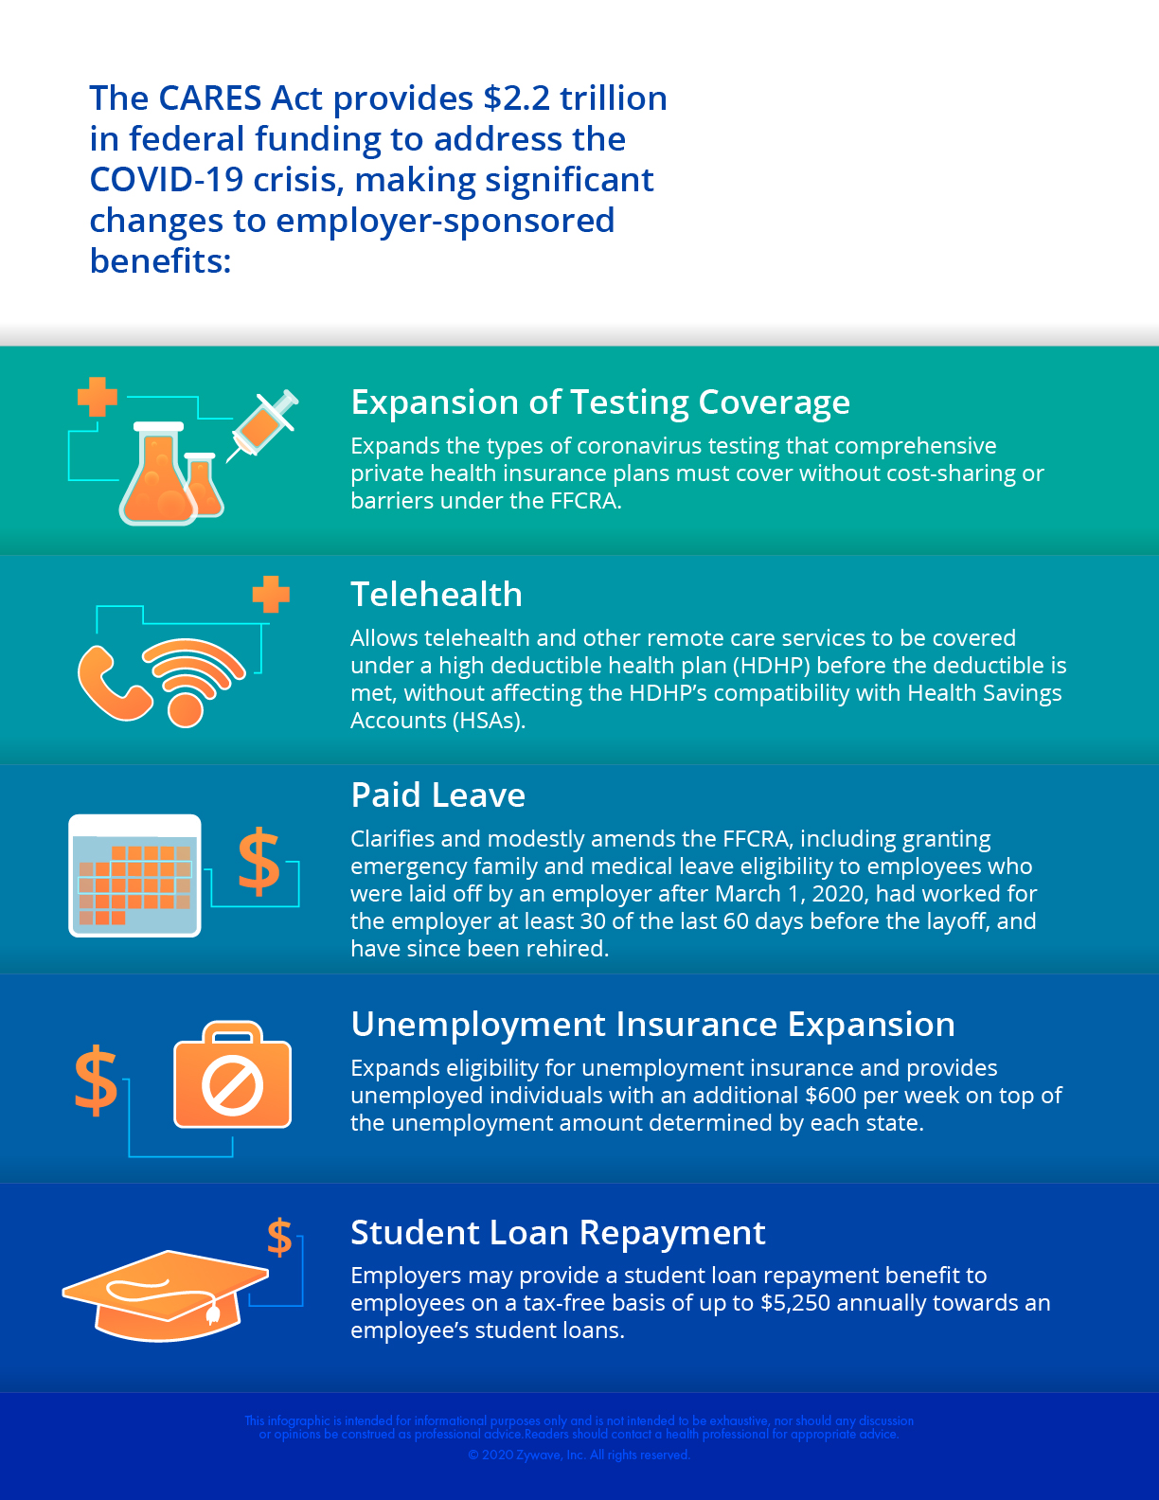
CARES Act Infographic

Essential Worker Employee Communications Letter

Dear employee,

Under the provisions of [insert state or local regulation], you are considered to be an essential employee of .
As such, you are required to maintain your normal work schedule so that can maintain proper operations as an essential business during the COVID-19 pandemic. If you have any questions or concerns about being an essential worker or the precautions is taking to protect its employees, contact your manager or HR.
In addition, if your manager distributes another letter explaining that you are an essential worker and must travel to and from work, please keep this letter in your car. It will be needed should law enforcement ask why you are not sheltering in place or staying at home.
Please contact [insert contact name] at [insert contact phone] with any questions. Thank you in advance for your cooperation and understanding.

Sincerely,

Emergency Paid Sick Leave Act – Leave Request Form
Employee Name Today’s Date

Employee Street Address

City State Zip Code
Does your spouse work for this company?
Yes | No
Reason for taking leave (check one):
I’m currently subject to a federal, state or local quarantine or isolation order related to COVID-19.
I’ve been advised by a health care provider to self-quarantine related to COVID-19.
I’m caring for an individual subject to a quarantine or isolation order.
I’m experiencing COVID-19 symptoms and seeking a medical diagnosis.
I’m caring for a child whose school or place of care is closed due to COVID-19.
I’m experiencing any other substantially similar condition specified by the U.S. Department of Health and Human Services.
Are you unable to work or telework due to the reason you specified?
Yes | No
Please complete the following section if your leave request is based on a quarantine order or self-quarantine advice.
Please provide the name of the governmental entity ordering quarantine or the name of the health care professional advising self-quarantine. If the person subject to quarantine or advised to self-quarantine is not you, provide that person’s name and your relation to the person:
Please complete the following section if your leave request is based on a school closing or child care provider unavailability.
Please provide the name and age of the child (or children) to be cared for, the name of the school that has closed or place of care that is unavailable, and a representation that no other person will be providing care for the child during the period for which you are receiving family medical leave. With respect to your inability to work or telework because of a need to provide care for a child older than 14 during daylight hours, please provide a statement that special circumstances exist requiring the employee to provide care:
Please complete the following section if leave will be taken continually or for the entire period.
Date leave will begin: Date of return to work:
Please complete the following section if leave will be taken intermittently (for permitted reasons and as agreed to by ).
Schedule of needed time off:
Employee Signature Date
Supervisor Signature Date

Essential Business Notification Letter

[Insert employee name]
[Insert employee address]
[Insert employee city, state and postal code]

RE:
Essential Business Identification (COVID-19)

Dear Sir or Madam,
Please be advised that , which provides [describe essential business function], is considered an essential business under local laws and guidelines. As [insert employee name] is an active employee of , please allow them to travel to and from our facility as part of their employment responsibilities. For reference, the employee’s typical schedule is as follows: [Insert schedule].
Thank you for your service as our employees continue to provide services as essential workers. Please feel free to contact me directly at [insert phone number] in the event you have any questions or concerns.
Sincerely,

[Insert name]
[Insert title]
[Insert phone number]

Note: To determine status as an essential or non-essential business, employers should consult with local guidelines.

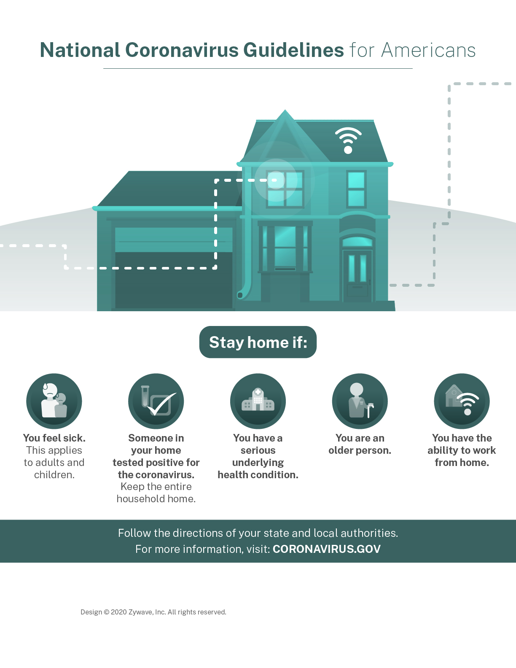
National Coronavirus Guidelines for Americans Poster

Sample Telecommuting Arrangement Announcement Letter

[Insert first name] [Insert last name]
[Insert home address]
[Insert city, state zip]

Dear Employee:
At , it is our priority to keep our employees and their families healthy. As the coronavirus disease 2019 (COVID-19) continues to spread globally, is taking appropriate precautions to address the outbreak by following guidelines from the Centers for Disease Control and Prevention (CDC).
We have made the difficult decision to temporarily close our offices until further notice. The closure will begin [insert date] and last through [insert date]. We believe that this decision is ultimately the best course of action to protect the health of our employees and their families.
At this time, employees should continue their work from the safety of their home. Employees should communicate their schedule and responsibilities with their manager in accordance with our Telecommuting Policy.
Employees should proactively notify their manager if they will NOT be able to work from home during a public health emergency. Additional details regarding the business continuity plan will be shared as relevant.
Given that this is a rapidly developing situation, we will continue to monitor developments and update our course of action as new information becomes available through the CDC. Contact your manager or HR with questions or to discuss any related issues.
Sincerely,
Employee Name Today’s Date

Employee Street Address

City State Zip Code
Does your spouse work for this company?
Yes | No
Reason for taking leave (check one):
The birth and care of my newborn child or placement of a child with me for adoption or foster care.
To care for my spouse, child or parent who has a serious health condition, including COVID-19.
To care for my child whose school or child care facility has been closed due to COVID-19.
My own serious health condition, including COVID-19, that makes me unable to perform at least one of the essential functions of my job.
To care for my spouse, child, parent or next of kin who is a covered service member with a serious injury or illness.
A qualifying exigency because my spouse, child or parent is a military member on covered active duty or call to covered active duty status.
Please complete the following section if leave will be taken continually or for the entire period.
Date Leave Will Begin: Date of Return to Work:
Please complete the following section if leave will be taken intermittently.
Schedule of needed time off:
Employee Signature Date
Supervisor Signature Date
Note: You must seek approval from the Company for intermittent or reduced schedule leave for the birth or placement of a child for adoption or foster care.

Emergency Family and Medical Leave Expansion Act – Leave Request Form

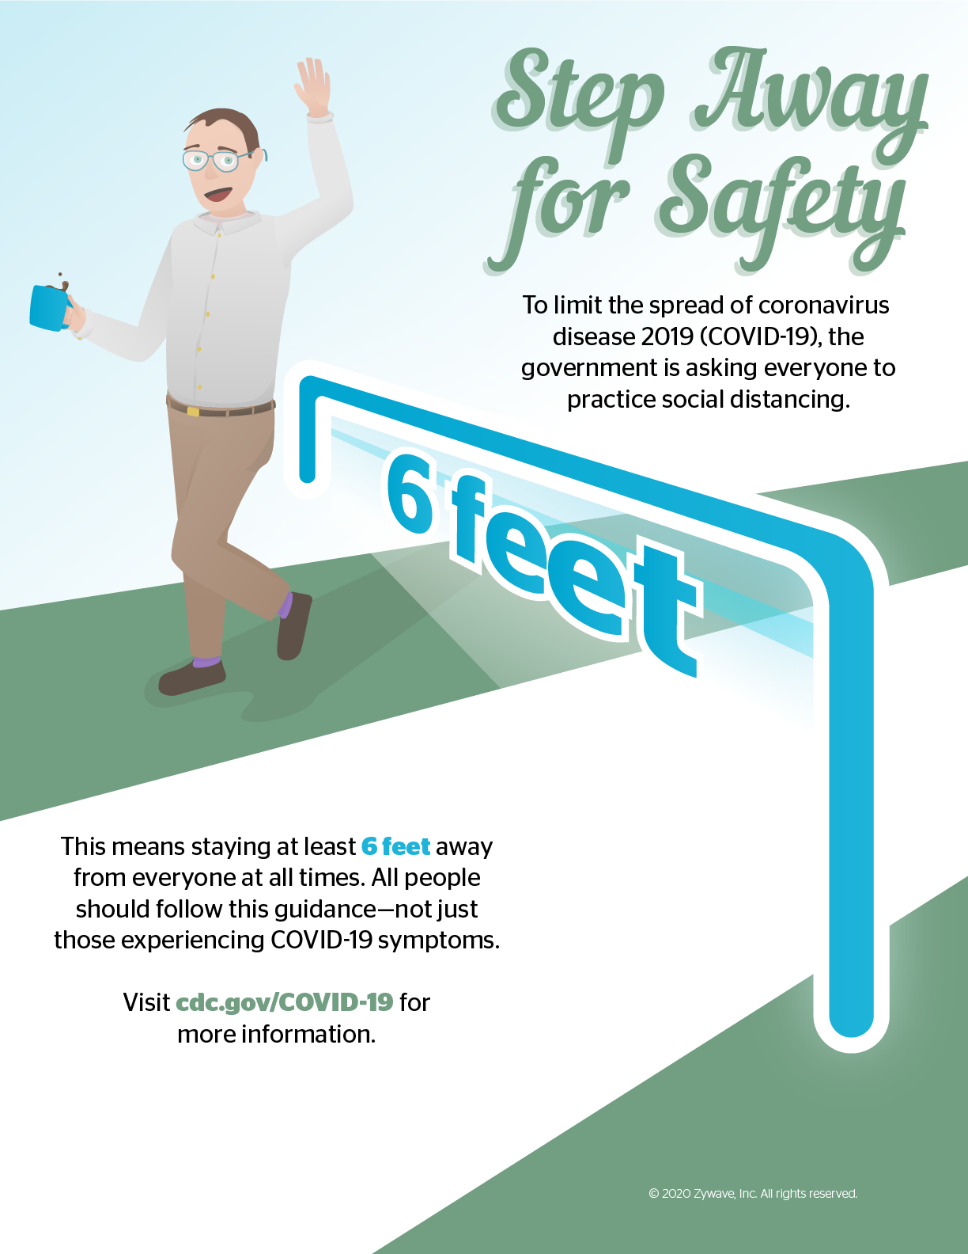
Social Distancing Poster

Workplace Coronavirus Infection Email to Employees

Dear [insert employee name],

recently discovered that one of our employees has tested positive for coronavirus disease 2019 (COVID-19). Your safety is our primary concern at all times, and this email continues our commitment to that goal.
We will continue to follow our workplace policies, which include proper disinfection and transparency with our employees. There is currently no reason to assume you are infected simply because this individual contracted COVID-19, but we understand your desire to be apprised to the situation.
To that end, please review these COVID-19 symptoms and monitor your health in the meantime:
- Difficulty breathing
- Rough, dry cough that hurts your chest
- Fever of at least 100 F
- Loss of taste or smell
Please continue to follow all workplace guidelines and speak with your manager with any questions or concerns related to this situation.
appreciates all your hard work and resilience during this uncertain period.

Best regards,

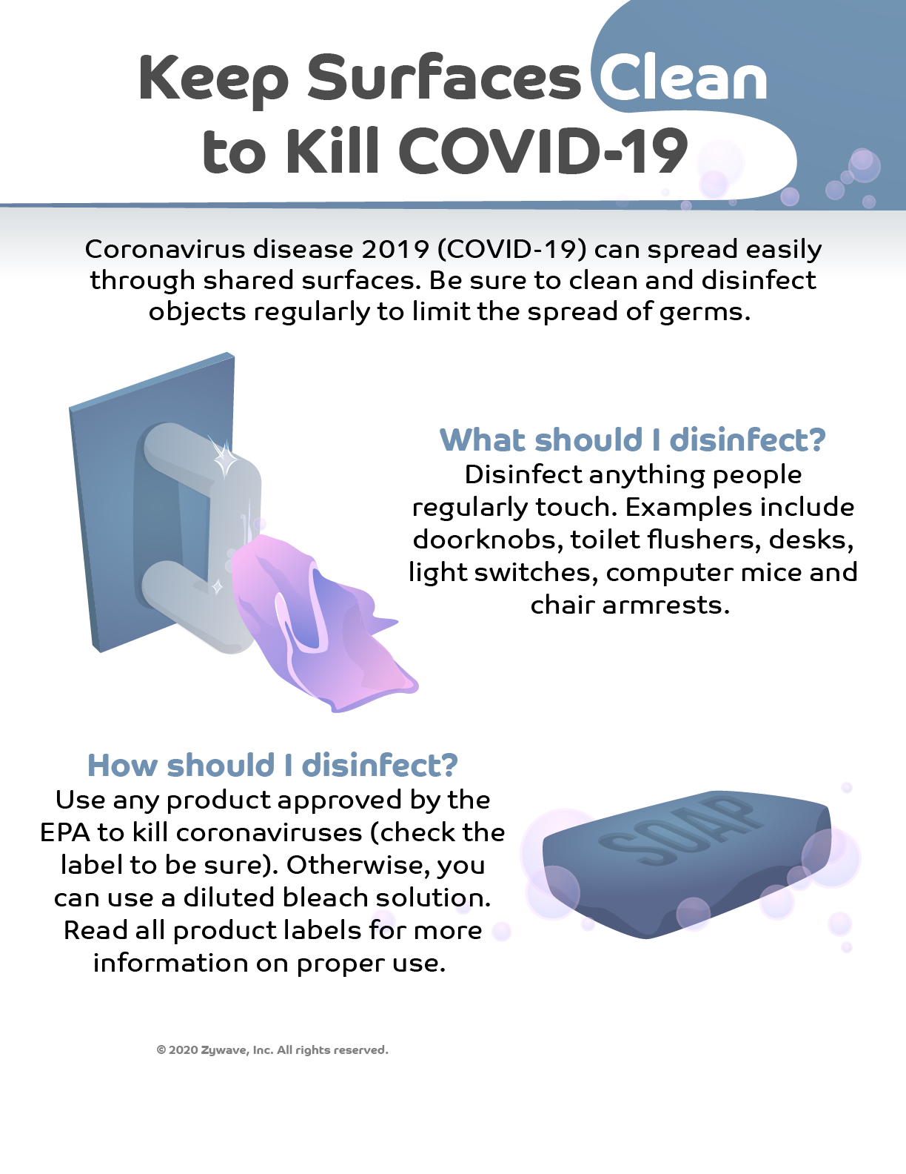
Keep Surfaces Clean to Kill COVID-19 – Poster

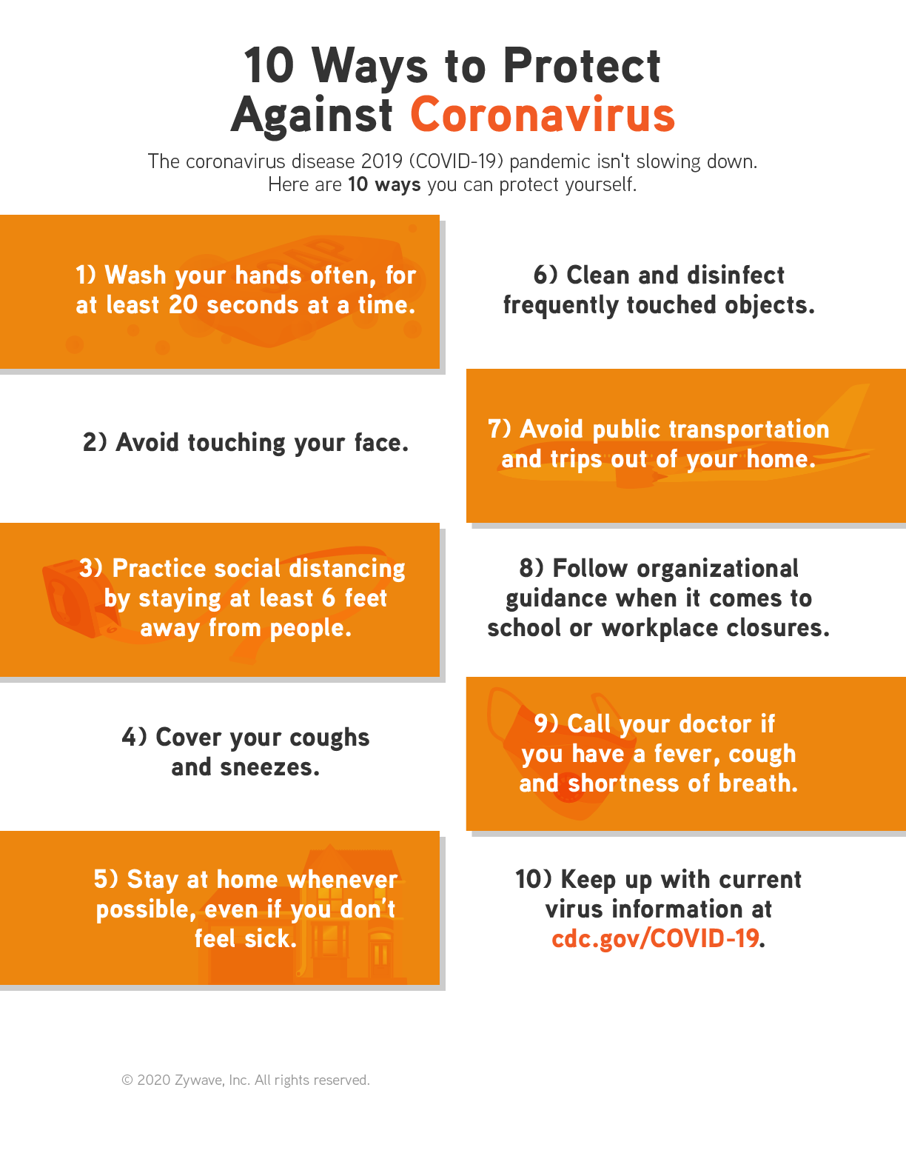
10 Ways to Protect Against Coronavirus - Poster

Office Closing for Coronavirus Pandemic Employee Communications Letter

[Insert first name] [Insert last name]
[Insert home address]
[Insert city, state zip]

Dear Employee:

At , it is our priority to keep our employees and their families healthy. As the coronavirus disease 2019 (COVID-19) continues to spread globally, is taking appropriate precautions to address the outbreak by following guidelines from the Centers for Disease Control and Prevention (CDC).
We have made the difficult decision to temporarily close our offices until further notice. The closure will begin [insert date] and last through [insert date]. We believe that this decision is ultimately the best course of action to protect the health of our employees and their families.
Given that this is a rapidly developing situation, we will continue to monitor developments and update our course of action as new information becomes available through the CDC. Contact your manager or HR with questions or to discuss any related issues.

Sincerely,

General Coronavirus Employee Communications Letter

[Insert first name] [Insert last name]
[Insert home address]
[Insert city, state zip]

Dear Employee:
At , it is our priority to keep our employees and their families healthy. As the coronavirus disease 2019 (COVID-19) continues to spread globally, is taking appropriate precautions to address the outbreak by following guidelines from the Centers for Disease Control and Prevention (CDC). Our current approach and response to COVID-19 are outlined below. Please read this information carefully and direct any follow-up questions to your manager or HR.
What is COVID-19?
COVID-19 is caused by a member of the coronavirus family, and it first appeared in late 2019 in Wuhan, China. Symptoms of COVID-19 can include fever, runny nose, cough and breathing trouble. While most people experience mild symptoms, some may develop more severe symptoms, which can be fatal.
COVID-19 is believed to be spread person to person, which means that infection can occur through close contact with infected individuals. Although it is believed that COVID-19 is most contagious when an infected individual is most symptomatic, an individual may still be contagious without exhibiting any symptoms.
Prevention Tips
According to the CDC, the best way to prevent the spread of COVID-19 is to avoid it. Do your part by practicing good hygiene at work and at home:
- Regularly wash your hands for at least 20 seconds throughout the day with warm water and soap, specifically before eating.
- Cover coughs and sneezes.
- Avoid making close contact with others, such as shaking hands.
- Avoid touching your eyes, nose and mouth.
- Frequently clean and disinfect commonly used surfaces with household cleaning spray or wipes.
To help you remain healthy, has hand sanitizer and disinfecting wipes available throughout the office. We have limited amounts of these supplies and will continue to restock as we are able. It is suggested you wash your hands more frequently than normal. Additionally, building management has instructed the office cleaning crew to disinfect key areas such as faucets and door handles on a daily basis.
For additional guidance on maintaining your health, see the CDC’s webpage on prevention and treatment.
Your Personal Health
If you have symptoms of acute respiratory illness, you should immediately seek medical attention and follow the guidance of your health care provider. If you are exhibiting symptoms, it is recommended you work remotely or take PTO. If you are diagnosed with or aware you’ve been directly exposed to COVID-19, please notify HR.
Travel
We are not placing a restriction on business travel at this time; however, unnecessary travel should be avoided, and employees should avoid travel to cities that have shut down due to a public health emergency.
Requests to adjust your upcoming travel should be discussed with your manager. Before traveling, please review your destination on the CDC’s webpage for specific travel advisories and precautions.
Working From Home
At this time, employees requesting telecommuting should continue to receive prior approval from their manager in accordance with our Telecommuting Policy. If unforeseen circumstances arise, communicate with your manager as soon as possible to request off-site work.
Employees should proactively notify their manager if they would NOT be able to work from home during a public health emergency. Additional details regarding the business continuity plan will be shared as relevant.
Given this is a rapidly developing situation, we will continue to monitor developments and update our course of action as new information becomes available through the CDC. In the meantime, please do your part to stay healthy, and be prepared for potential disruptions. Contact your manager or HR with questions or to discuss any related issues.
Sincerely,

